# Broken Links Report

• Broken link on <https://www.utep.edu/liberalarts/art/about/art-in-the-community.html> on **Main Content (Top small navigation)** section, the broken link is displayed as: **About** and the link is pointing to : <https://www.utep.edu/liberalarts/art/about/>

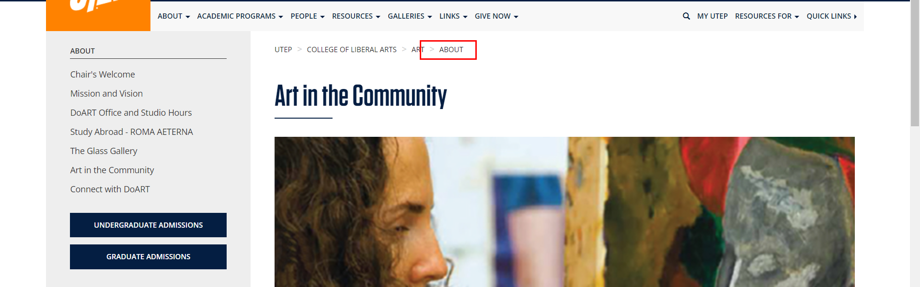

• Broken link on <https://www.utep.edu/liberalarts/art/about/contact-us.html> on **Main Content (Top small navigation)** section, the broken link is displayed as: **About** and the link is pointing to : <https://www.utep.edu/liberalarts/art/about/>

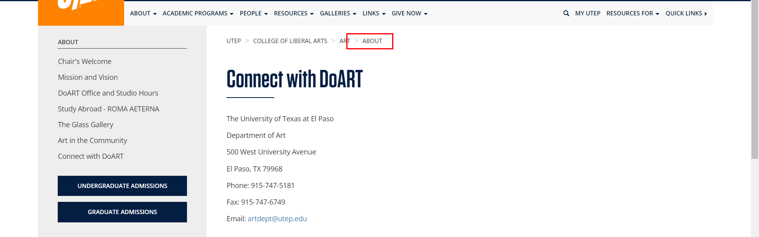

• Broken link on <https://www.utep.edu/liberalarts/art/about/message-from-the-chair.html> on **Main Content (Top small navigation)** section, the broken link is displayed as: **About** and the link is pointing to : <https://www.utep.edu/liberalarts/art/about/>

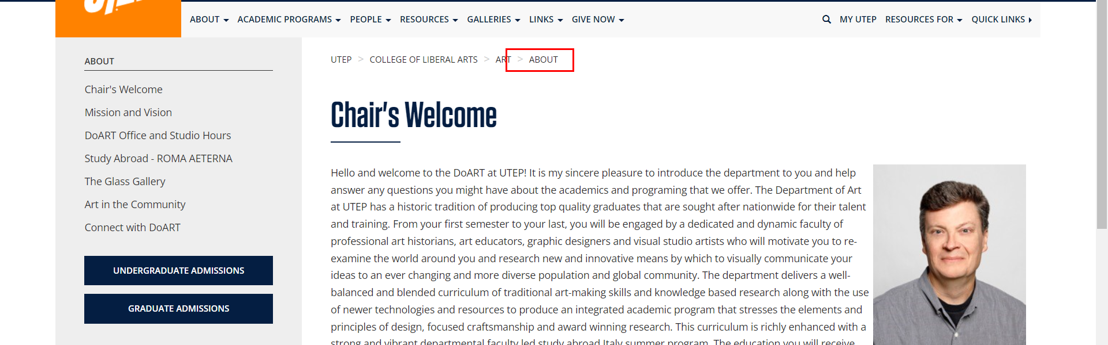

• Broken link on <https://www.utep.edu/liberalarts/art/about/mission-and-vision.html> on **Main Content (Top small navigation)** section, the broken link is displayed as: **About** and the link is pointing to : <https://www.utep.edu/liberalarts/art/about/>

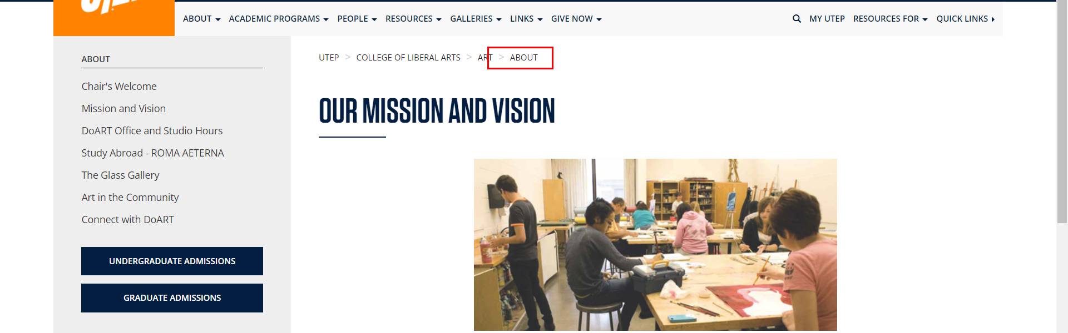

• Broken link on <https://www.utep.edu/liberalarts/art/about/the-glass-gallery.html> on **Main Content (Top small navigation)** section, the broken link is displayed as: **About** and the link is pointing to : <https://www.utep.edu/liberalarts/art/about/>

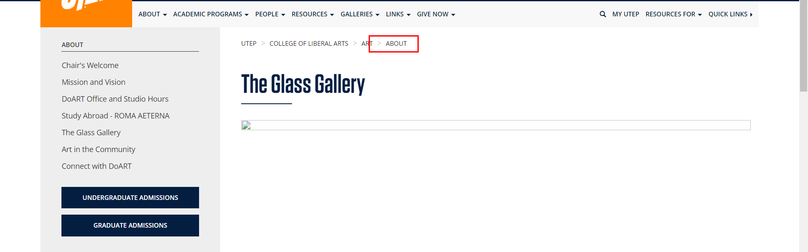

• Broken link on <https://www.utep.edu/liberalarts/art/about/utep-department-of-art.html> on **Main Content (Top small navigation)** section, the broken link is displayed as: **About** and the link is pointing to : <https://www.utep.edu/liberalarts/art/about/>

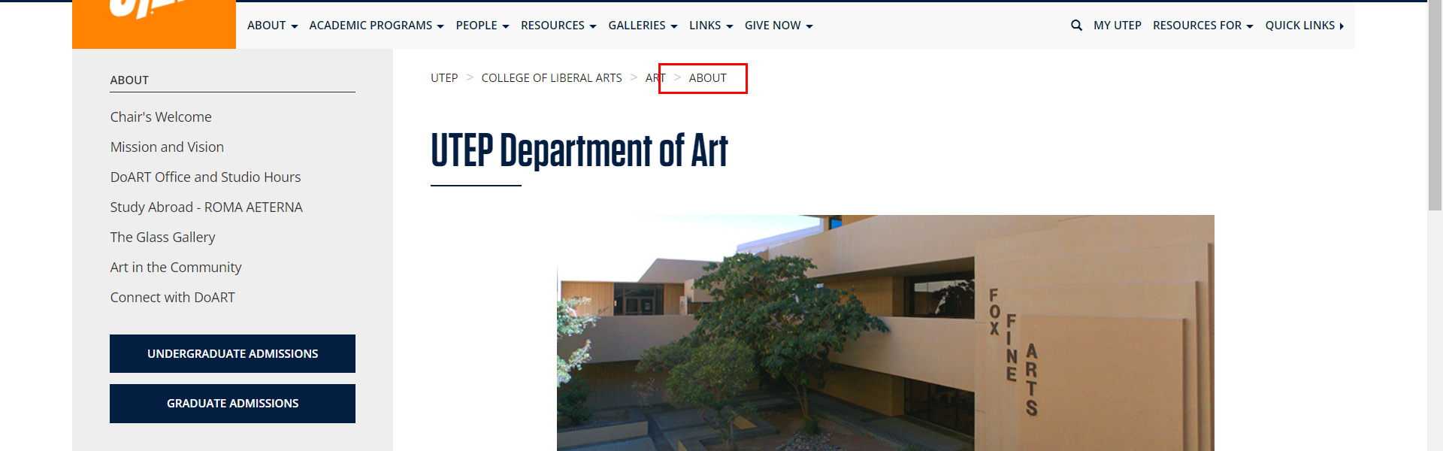

• Broken link on <https://www.utep.edu/liberalarts/art/academic-programs/rubin-center/rubin-center-faculty.html> on **Main Content (Top small navigation)** section, the broken link is displayed as: **rubin-center** and the link is pointing to : <https://www.utep.edu/liberalarts/art/academic-programs/rubin-center/>

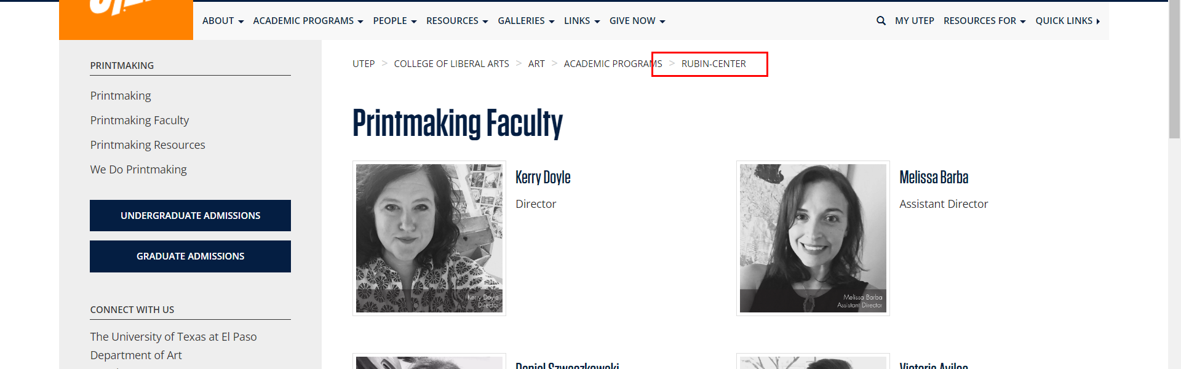

• Broken link on <https://www.utep.edu/liberalarts/art/academic-programs/undergraduate/art-appreciation/art-appreciation-faculty.html> on **Main Content (Top small navigation)** section, the broken link is displayed as: **art-appreciation** and the link is pointing to : <https://www.utep.edu/liberalarts/art/academic-programs/undergraduate/art-appreciation/>

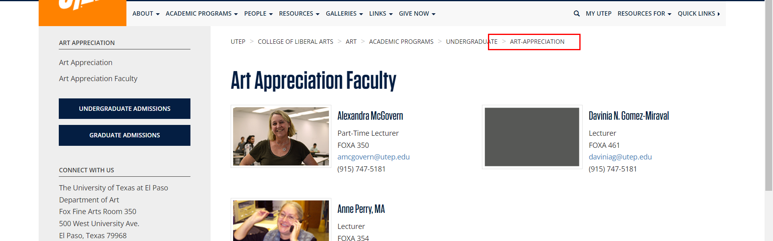

• Broken link on <https://www.utep.edu/liberalarts/art/academic-programs/undergraduate/art-appreciation/art-appreciation.html> on **Main Content (Top small navigation)** section, the broken link is displayed as: **art-appreciation** and the link is pointing to : <https://www.utep.edu/liberalarts/art/academic-programs/undergraduate/art-appreciation/>

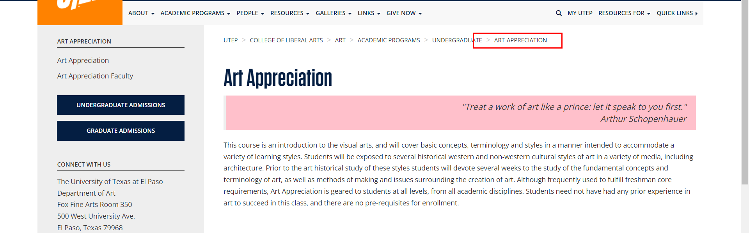

• Broken link on <https://www.utep.edu/liberalarts/art/academic-programs/undergraduate/art-education/art-education-faculty.html> on **Main Content (Top small navigation)** section, the broken link is displayed as: **art-education** and the link is pointing to : <https://www.utep.edu/liberalarts/art/academic-programs/undergraduate/art-education/>

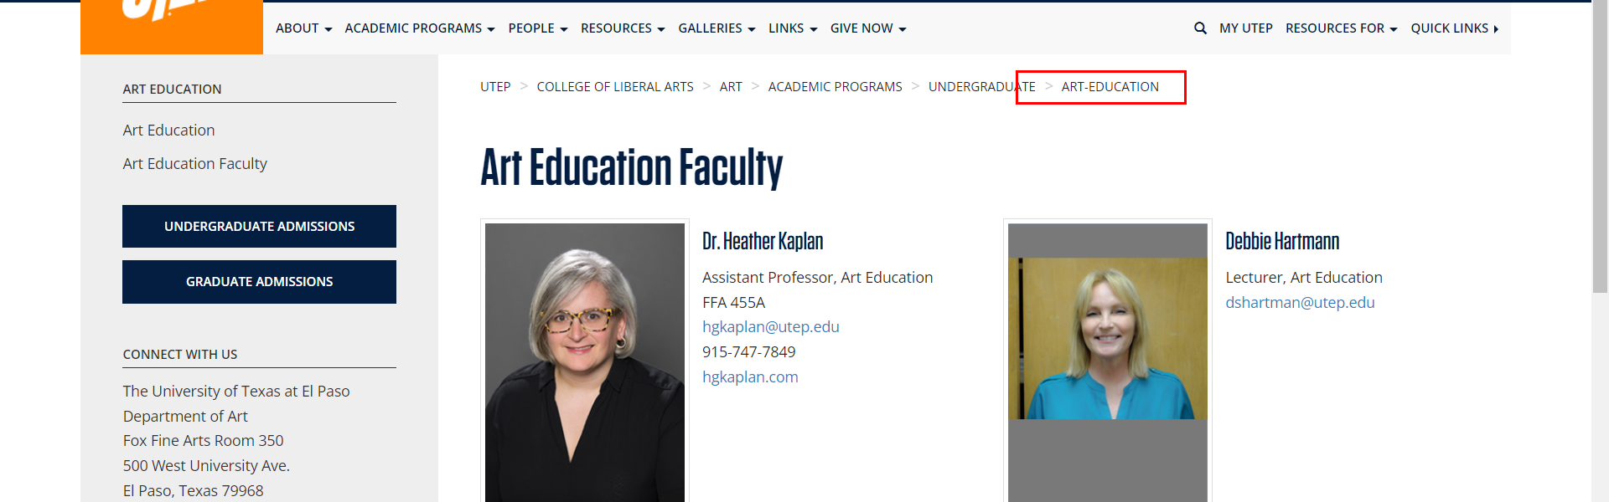

• Broken link on <https://www.utep.edu/liberalarts/art/academic-programs/undergraduate/art-education/art-education.html> on **Main Content (Top small navigation)** section, the broken link is displayed as: **art-education** and the link is pointing to : <https://www.utep.edu/liberalarts/art/academic-programs/undergraduate/art-education/>

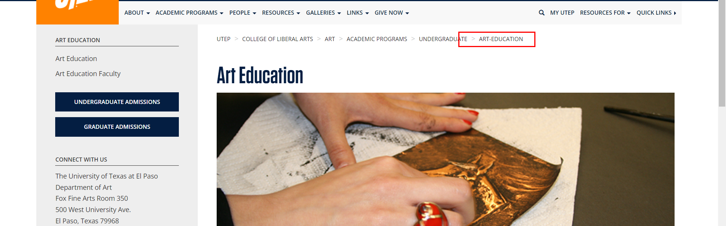

• Broken link on <https://www.utep.edu/liberalarts/art/academic-programs/undergraduate/art-history/art-history-faculty.html> on **Main Content (Top small navigation)** section, the broken link is displayed as: **art-history** and the link is pointing to : <https://www.utep.edu/liberalarts/art/academic-programs/undergraduate/art-history/>

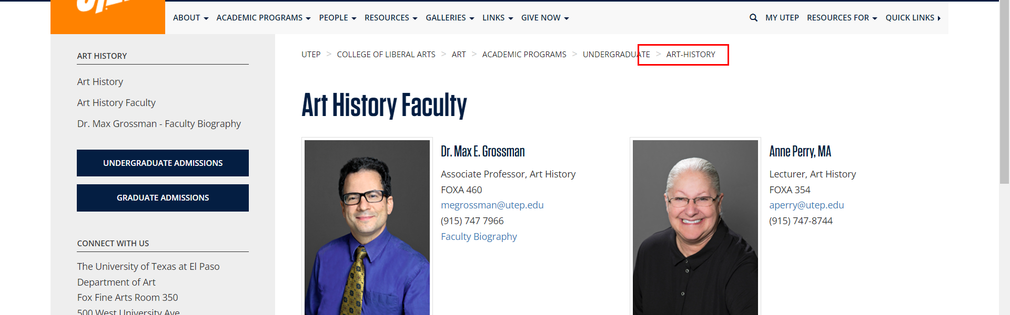

• Broken link on <https://www.utep.edu/liberalarts/art/academic-programs/undergraduate/art-history/art-history.html> on **Main Content (Top small navigation)** section, the broken link is displayed as: **art-history** and the link is pointing to : <https://www.utep.edu/liberalarts/art/academic-programs/undergraduate/art-history/>

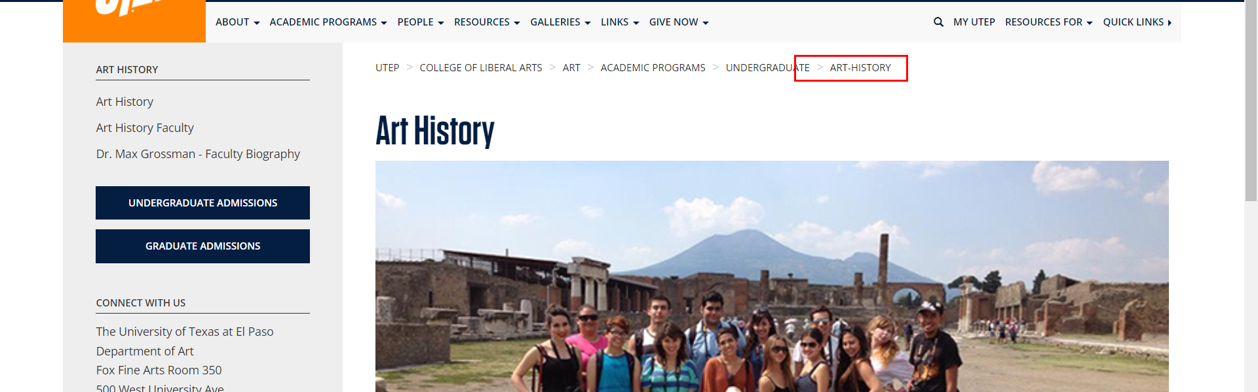

• Broken link on <https://www.utep.edu/liberalarts/art/academic-programs/undergraduate/art-history/dr-melissa-warak.html> on **Main Content (Top small navigation)** section, the broken link is displayed as: **art-history** and the link is pointing to : <https://www.utep.edu/liberalarts/art/academic-programs/undergraduate/art-history/>

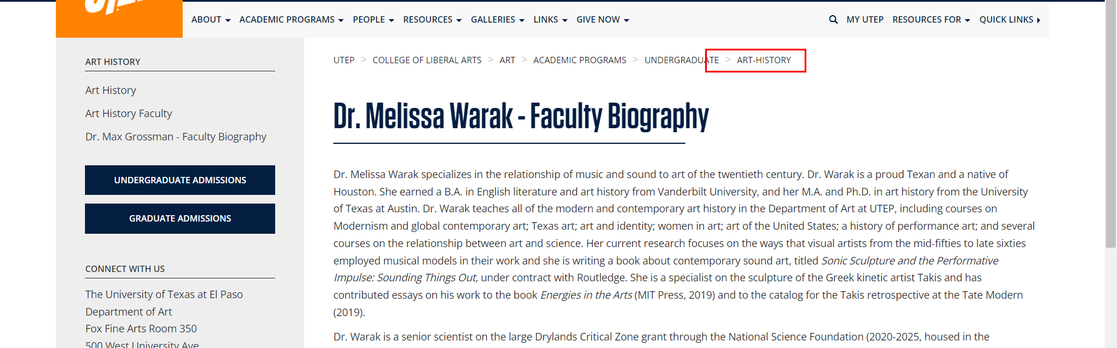

• Broken link on <https://www.utep.edu/liberalarts/art/academic-programs/undergraduate/ceramics/ceramics-faculty.html> on **Main Content (Top small navigation)** section, the broken link is displayed as: **ceramics** and the link is pointing to : <https://www.utep.edu/liberalarts/art/academic-programs/undergraduate/ceramics/>

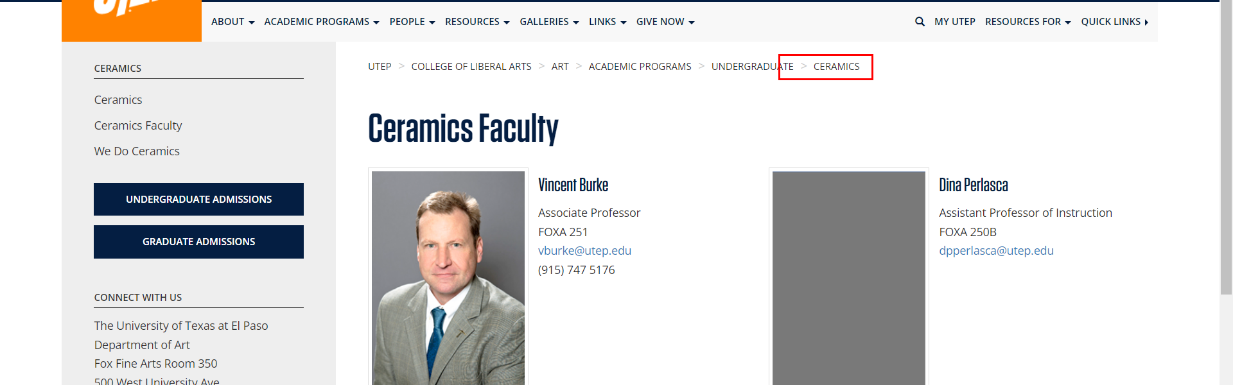

• Broken link on <https://www.utep.edu/liberalarts/art/academic-programs/undergraduate/ceramics/ceramics.html> on **Main Content (Top small navigation)** section, the broken link is displayed as: **ceramics** and the link is pointing to : <https://www.utep.edu/liberalarts/art/academic-programs/undergraduate/ceramics/>

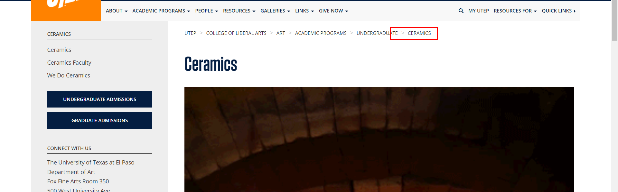

• Broken link on <https://www.utep.edu/liberalarts/art/academic-programs/undergraduate/ceramics/we-do-ceramics-test.html> on **Main Content (Top small navigation)** section, the broken link is displayed as: **ceramics** and the link is pointing to : <https://www.utep.edu/liberalarts/art/academic-programs/undergraduate/ceramics/>

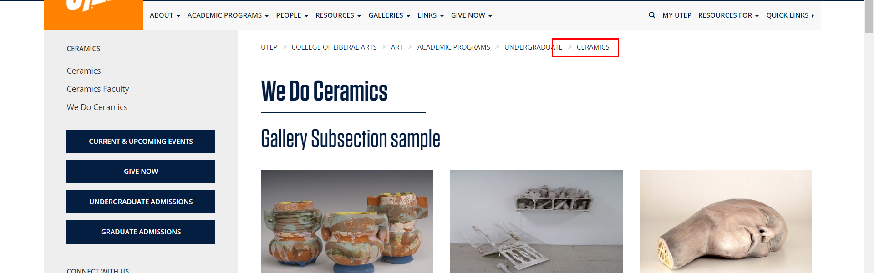

• Broken link on <https://www.utep.edu/liberalarts/art/academic-programs/undergraduate/ceramics/we-do-ceramics.html> on **Main Content (Top small navigation)** section, the broken link is displayed as: **ceramics** and the link is pointing to : <https://www.utep.edu/liberalarts/art/academic-programs/undergraduate/ceramics/>

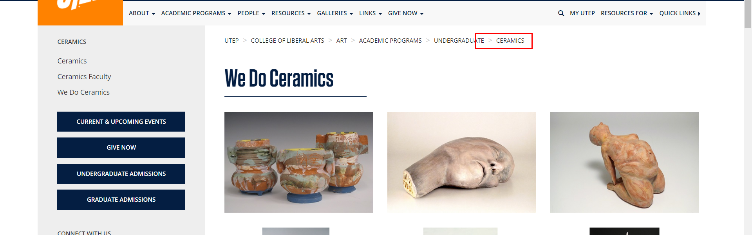

• Broken link on <https://www.utep.edu/liberalarts/art/academic-programs/undergraduate/drawing/drawing-faculty.html> on **Main Content (Top small navigation)** section, the broken link is displayed as: **drawing** and the link is pointing to : <https://www.utep.edu/liberalarts/art/academic-programs/undergraduate/drawing/>

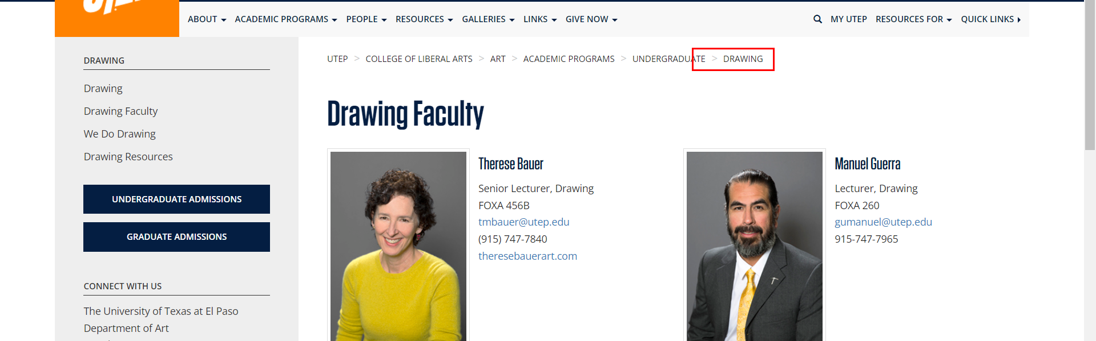

• Broken link on <https://www.utep.edu/liberalarts/art/academic-programs/undergraduate/drawing/drawing-resources.html> on **Main Content** section, the broken link is displayed as: **dickblick.com** and the link is pointing to : <https://www.utep.edu/liberalarts/art/academic-programs/undergraduate/drawing/dickblick.com>

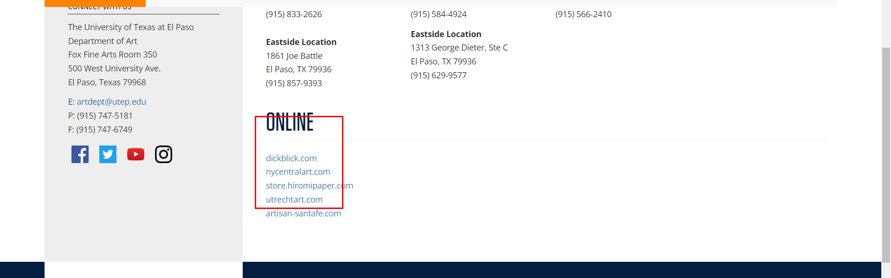

• Broken link on <https://www.utep.edu/liberalarts/art/academic-programs/undergraduate/drawing/drawing-resources.html> on **Main Content (Top small navigation)** section, the broken link is displayed as: **drawing** and the link is pointing to : <https://www.utep.edu/liberalarts/art/academic-programs/undergraduate/drawing/>

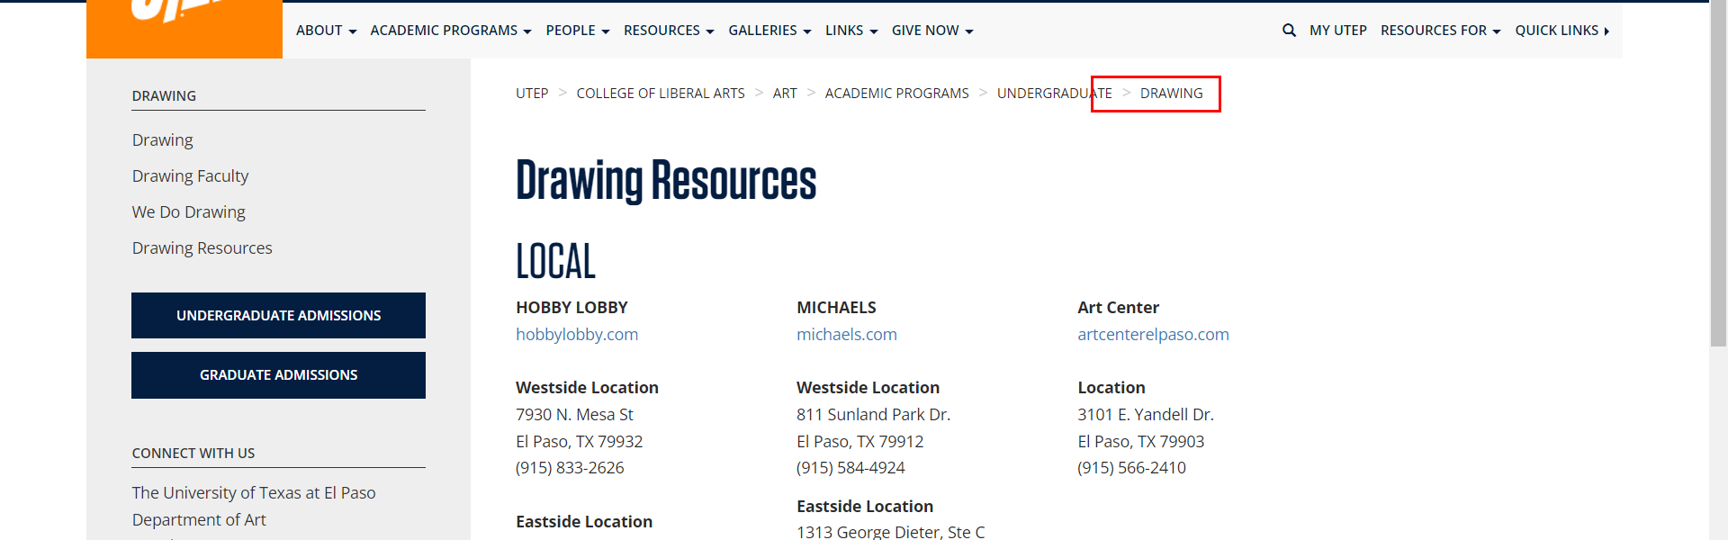

• Broken link on <https://www.utep.edu/liberalarts/art/academic-programs/undergraduate/drawing/drawing.html> on **Main Content (Top small navigation)** section, the broken link is displayed as: **drawing** and the link is pointing to : <https://www.utep.edu/liberalarts/art/academic-programs/undergraduate/drawing/>

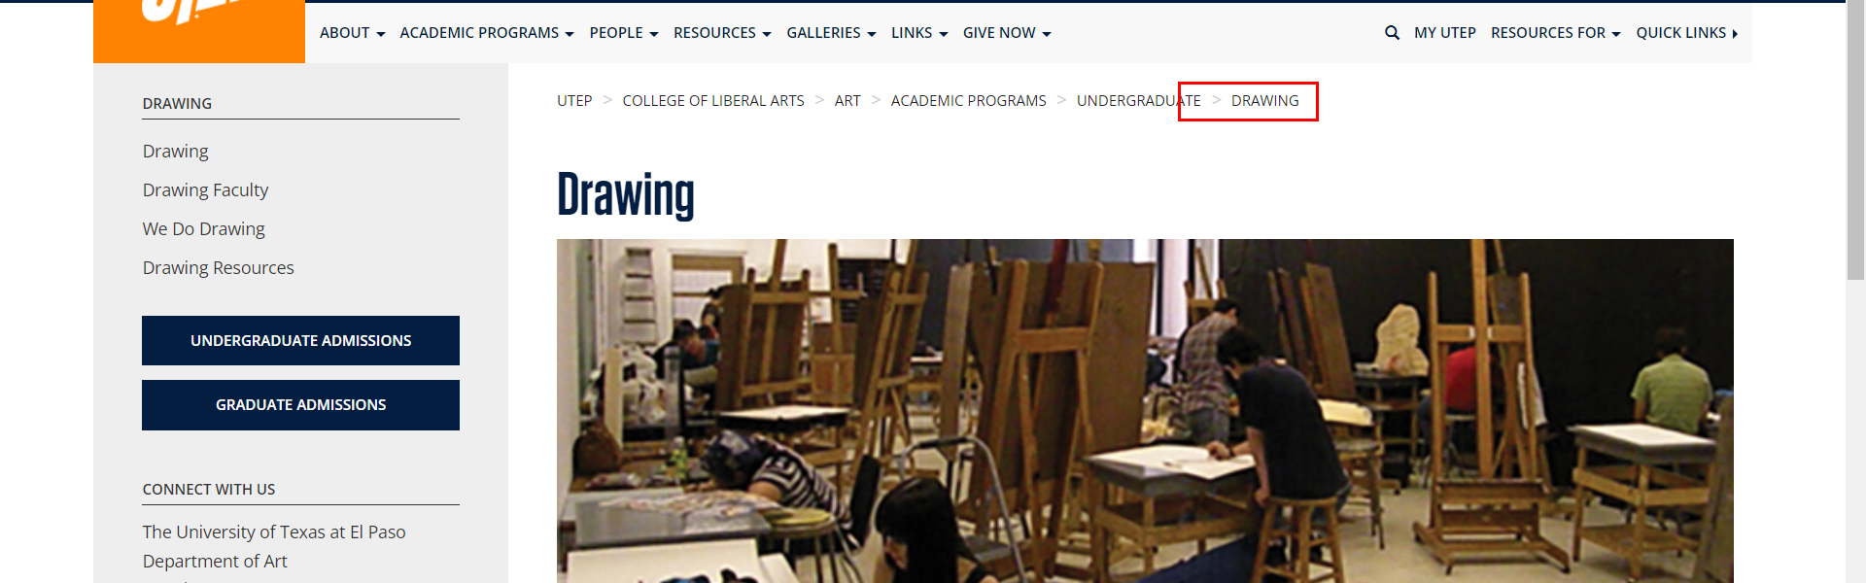

• Broken link on <https://www.utep.edu/liberalarts/art/academic-programs/undergraduate/drawing/we-do-drawing.html> on **Main Content (Top small navigation)** section, the broken link is displayed as: **drawing** and the link is pointing to : <https://www.utep.edu/liberalarts/art/academic-programs/undergraduate/drawing/>

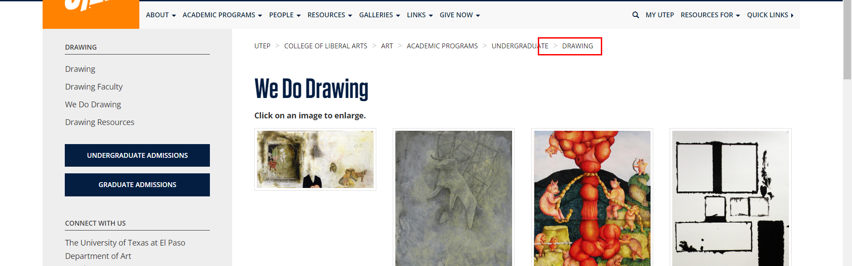

• Broken link on <https://www.utep.edu/liberalarts/art/academic-programs/undergraduate/foundations/foundations-faculty.html> on **Main Content (Top small navigation)** section, the broken link is displayed as: **foundations** and the link is pointing to : <https://www.utep.edu/liberalarts/art/academic-programs/undergraduate/foundations/>

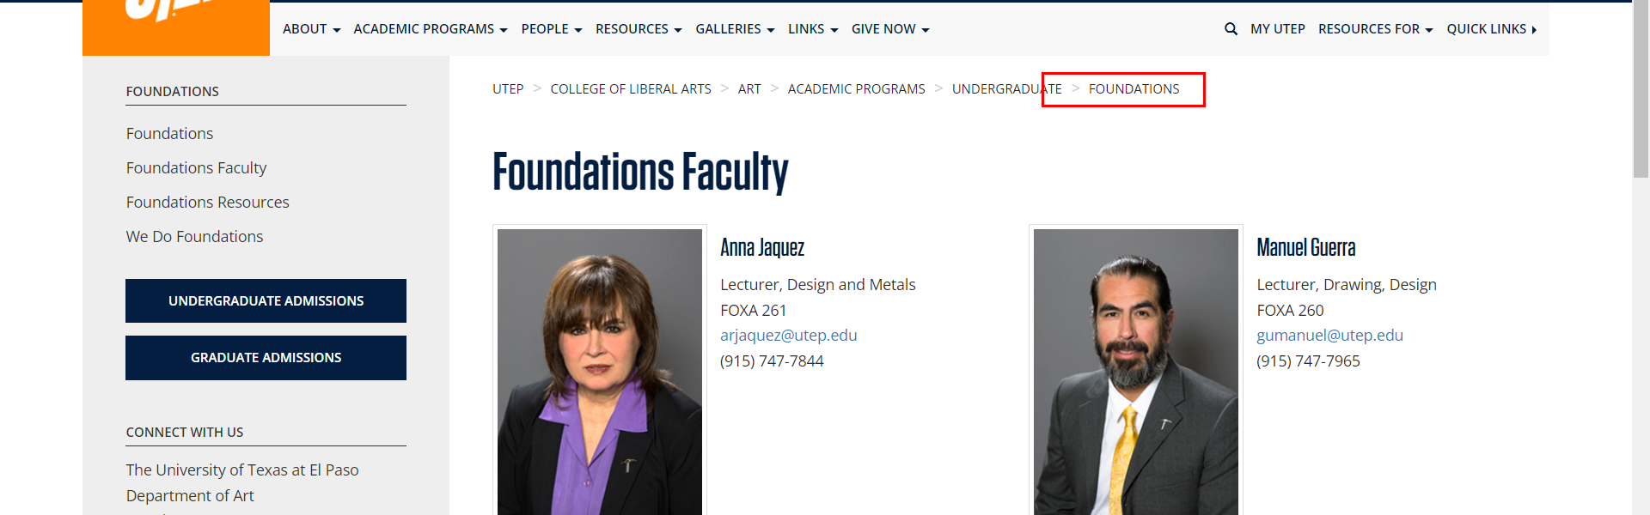

• Broken link on <https://www.utep.edu/liberalarts/art/academic-programs/undergraduate/foundations/foundations-resources.html> on **Main Content (Top small navigation)** section, the broken link is displayed as: **foundations** and the link is pointing to : <https://www.utep.edu/liberalarts/art/academic-programs/undergraduate/foundations/>

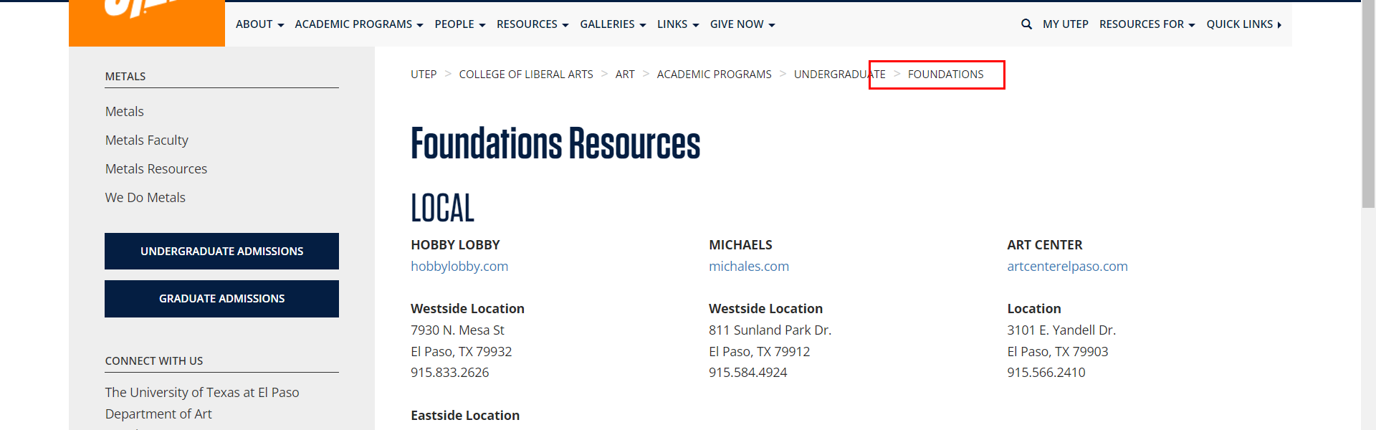

• Broken link on <https://www.utep.edu/liberalarts/art/academic-programs/undergraduate/foundations/foundations-resources.html> on **Main Content** section, the broken link is displayed as: **lowes.com** and the link is pointing to : <http://www.lowes.com>

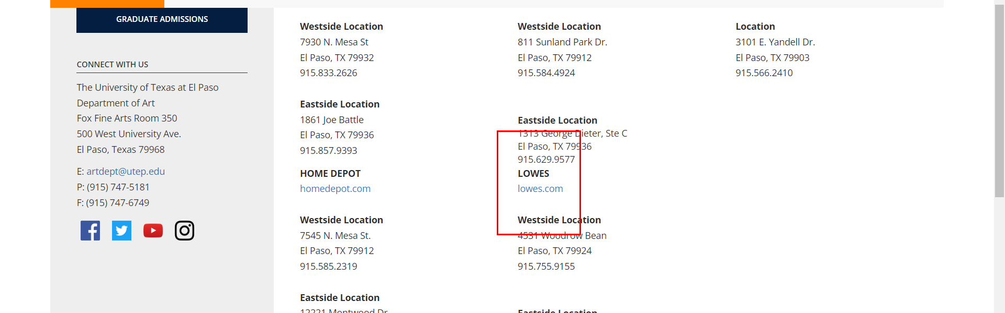

• Broken link on <https://www.utep.edu/liberalarts/art/academic-programs/undergraduate/foundations/foundations.html> on **Main Content (Top small navigation)** section, the broken link is displayed as: **foundations** and the link is pointing to : <https://www.utep.edu/liberalarts/art/academic-programs/undergraduate/foundations/>

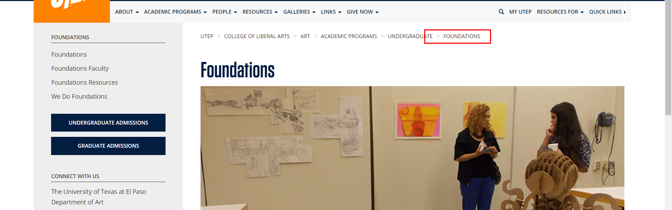

• Broken link on <https://www.utep.edu/liberalarts/art/academic-programs/undergraduate/foundations/we-do-foundations.html> on **Main Content (Top small navigation)** section, the broken link is displayed as: **foundations** and the link is pointing to : <https://www.utep.edu/liberalarts/art/academic-programs/undergraduate/foundations/>

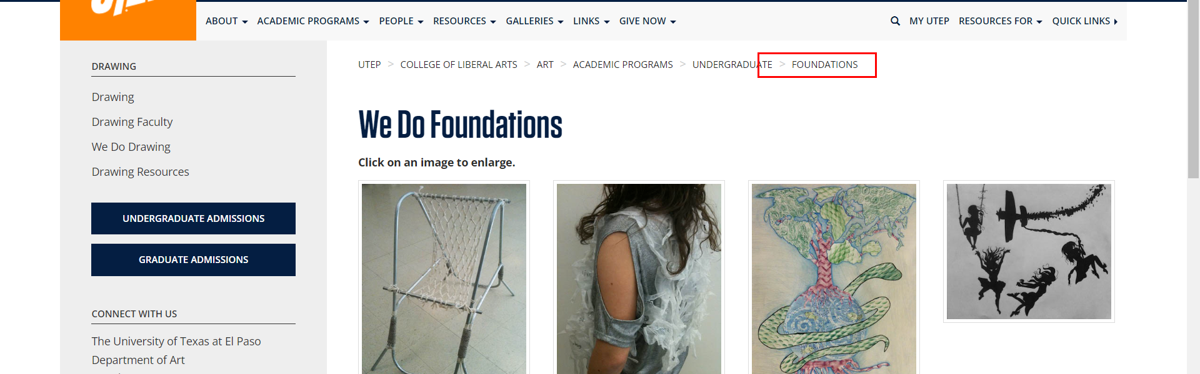

• Broken link on <https://www.utep.edu/liberalarts/art/academic-programs/undergraduate/graphic-design/graphic-design-faculty.html> on **Main Content (Top small navigation)** section, the broken link is displayed as: **graphic-design** and the link is pointing to : <https://www.utep.edu/liberalarts/art/academic-programs/undergraduate/graphic-design/>

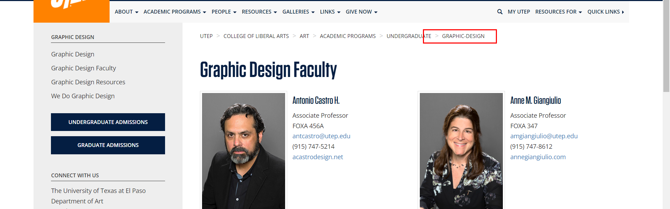

• Broken link on <https://www.utep.edu/liberalarts/art/academic-programs/undergraduate/graphic-design/graphic-design-resources.html> on **Main Content (Top small navigation)** section, the broken link is displayed as: **graphic-design** and the link is pointing to : <https://www.utep.edu/liberalarts/art/academic-programs/undergraduate/graphic-design/>

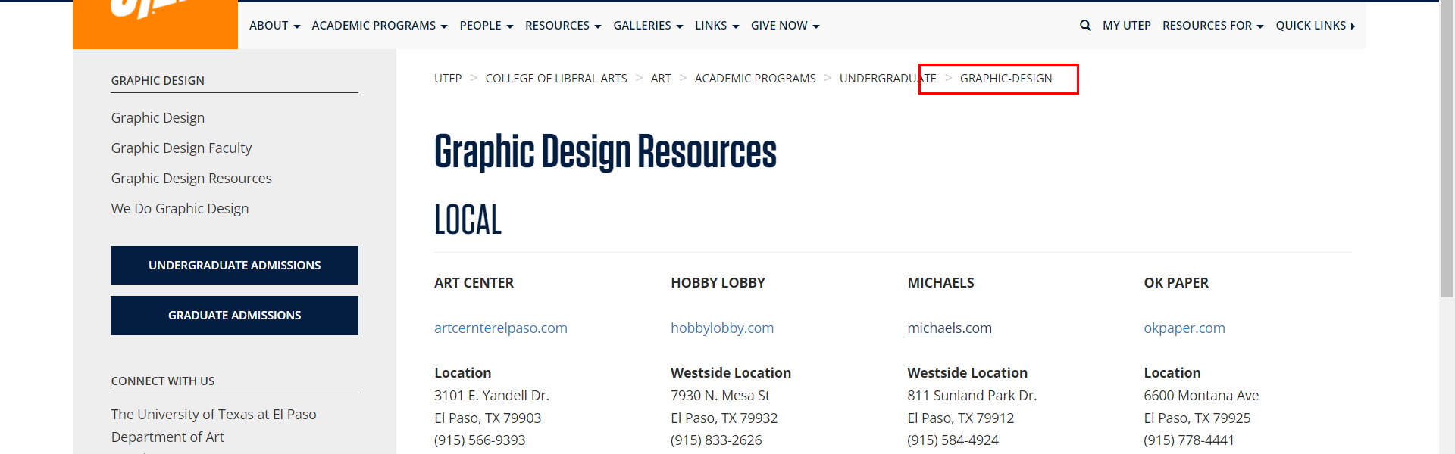

• Broken link on <https://www.utep.edu/liberalarts/art/academic-programs/undergraduate/graphic-design/graphic-design.html> on **Main Content (Top small navigation)** section, the broken link is displayed as: **graphic-design** and the link is pointing to : <https://www.utep.edu/liberalarts/art/academic-programs/undergraduate/graphic-design/>

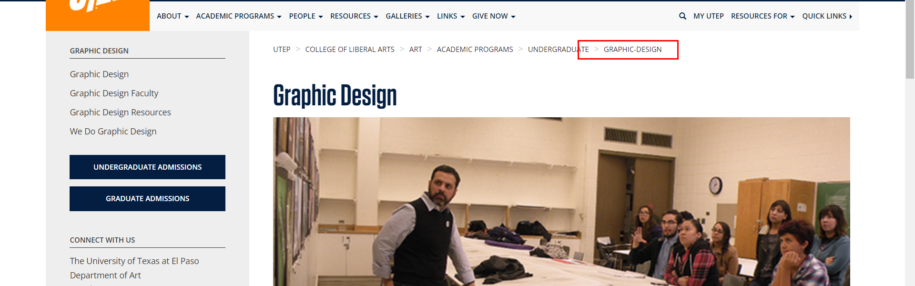

• Broken link on <https://www.utep.edu/liberalarts/art/academic-programs/undergraduate/graphic-design/we-do-graphic-design.html> on **Main Content (Top small navigation)** section, the broken link is displayed as: **graphic-design** and the link is pointing to : <https://www.utep.edu/liberalarts/art/academic-programs/undergraduate/graphic-design/>

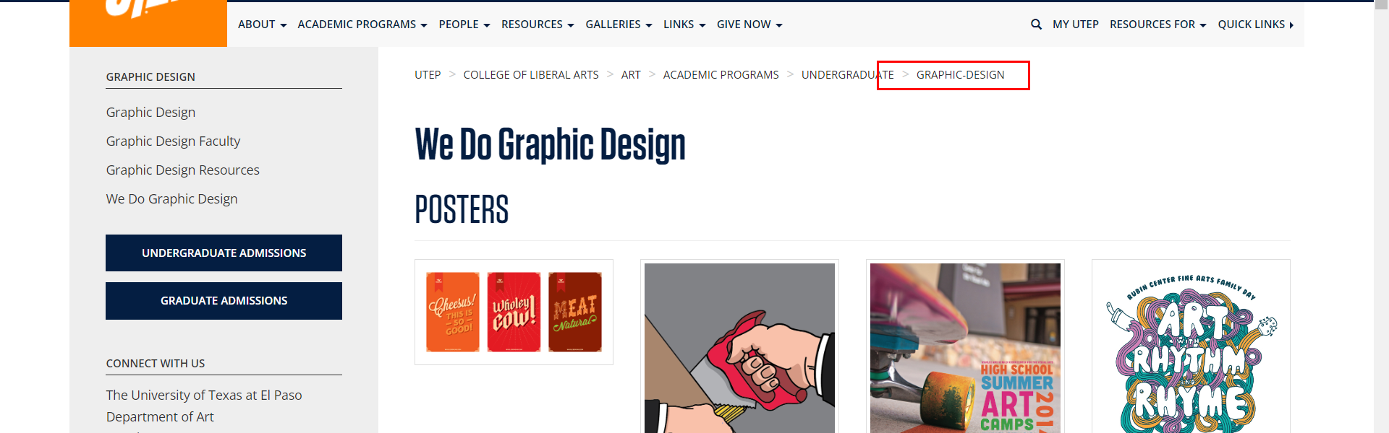

• Broken link on <https://www.utep.edu/liberalarts/art/academic-programs/undergraduate/graphic-design/we-do-graphic-design.html> on **Main Content** section, the broken link is displayed as: and the link is pointing to : [http://utminers.utep.edu/agramos/](https://utminers.utep.edu/agramos/)

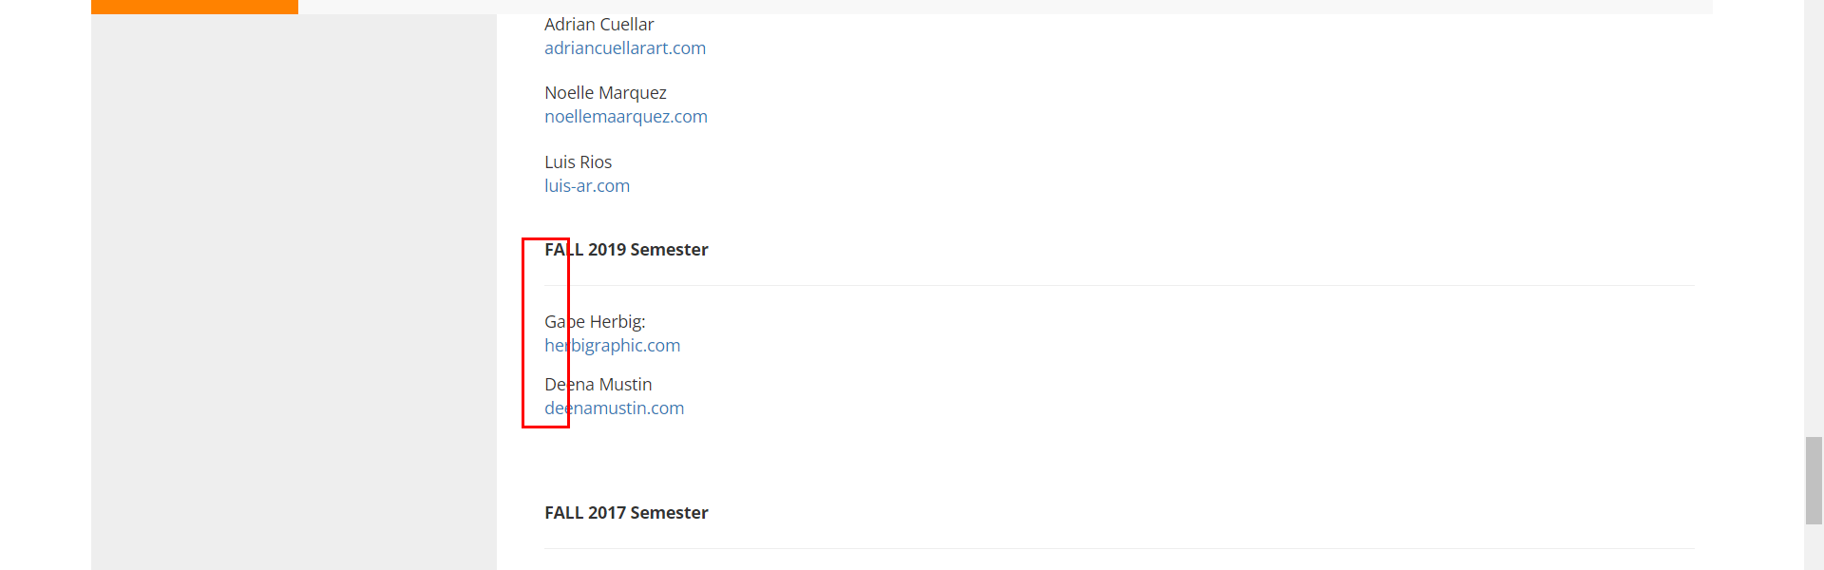

• Broken link on <https://www.utep.edu/liberalarts/art/academic-programs/undergraduate/graphic-design/we-do-graphic-design.html> on **Main Content** section, the broken link is displayed as: and the link is pointing to : [http://utminers.utep.edu/aoloya//](https://utminers.utep.edu/aoloya/)



• Broken link on <https://www.utep.edu/liberalarts/art/academic-programs/undergraduate/metals/carrousel.html> on **Main Content (Top small navigation)** section, the broken link is displayed as: **metals** and the link is pointing to : <https://www.utep.edu/liberalarts/art/academic-programs/undergraduate/metals/>

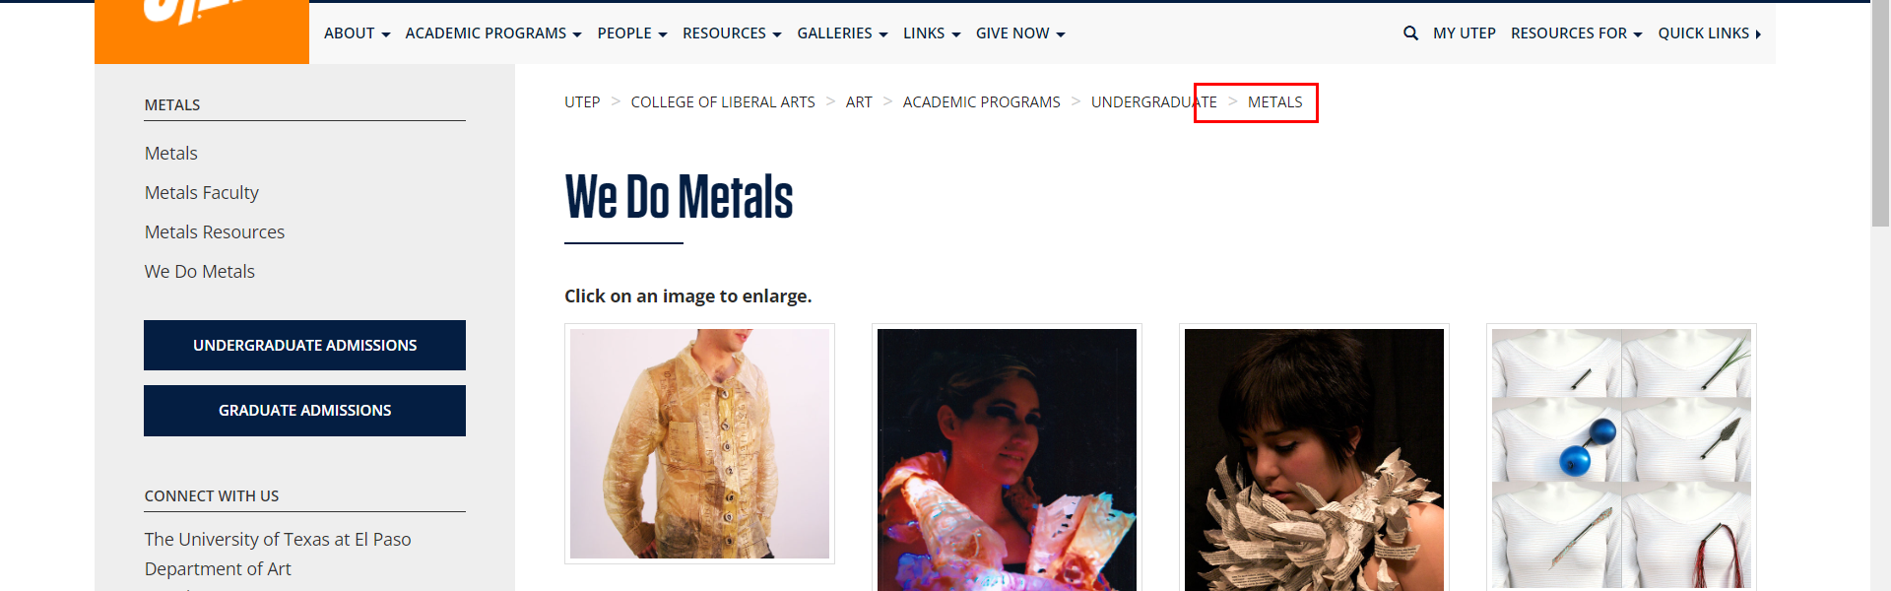

• Broken link on <https://www.utep.edu/liberalarts/art/academic-programs/undergraduate/metals/metals-faculty.html> on **Main Content (Top small navigation)** section, the broken link is displayed as: **metals** and the link is pointing to : <https://www.utep.edu/liberalarts/art/academic-programs/undergraduate/metals/>

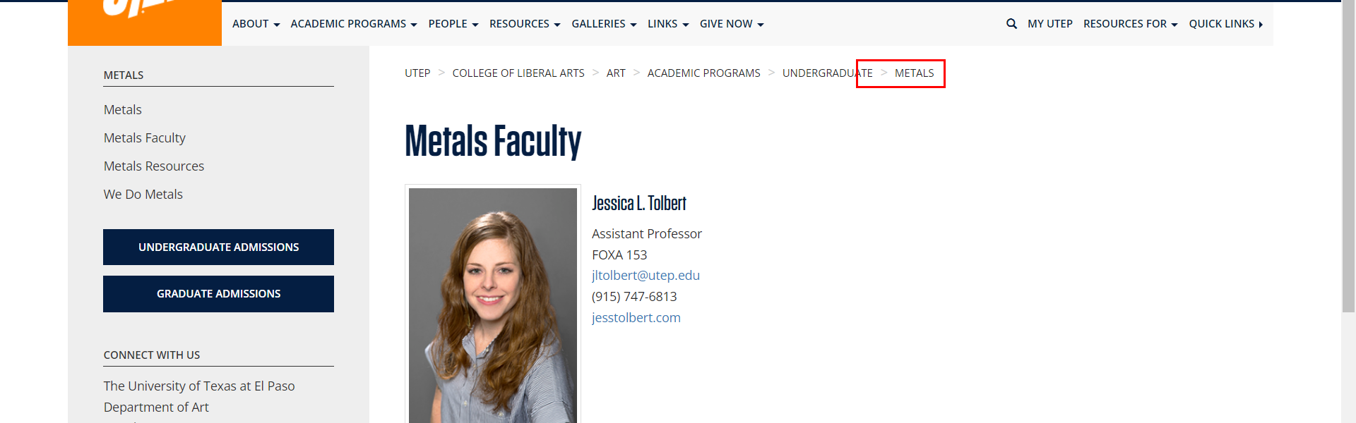

• Broken link on <https://www.utep.edu/liberalarts/art/academic-programs/undergraduate/metals/metals-resources.html> on **Main Content (Top small navigation)** section, the broken link is displayed as: **metals** and the link is pointing to : <https://www.utep.edu/liberalarts/art/academic-programs/undergraduate/metals/>

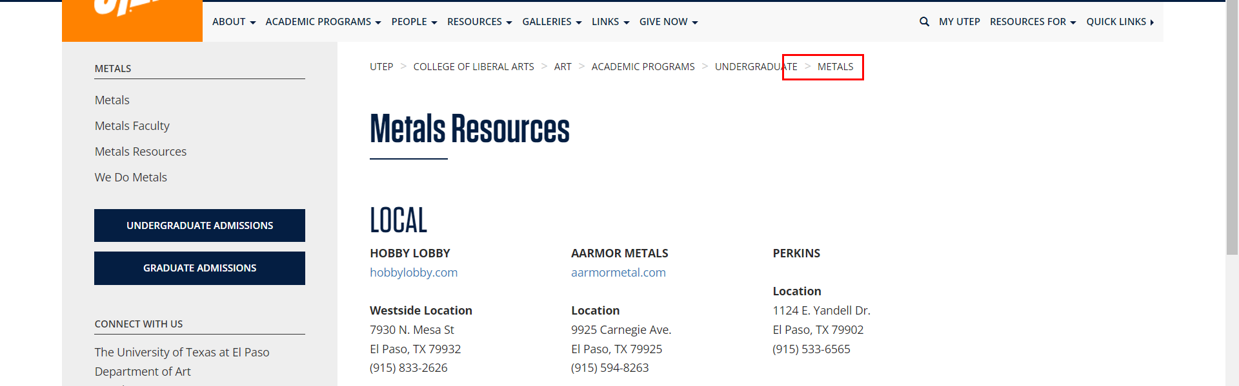

• Broken link on <https://www.utep.edu/liberalarts/art/academic-programs/undergraduate/metals/metals.html> on **Main Content (Top small navigation)** section, the broken link is displayed as: **metals** and the link is pointing to : <https://www.utep.edu/liberalarts/art/academic-programs/undergraduate/metals/>

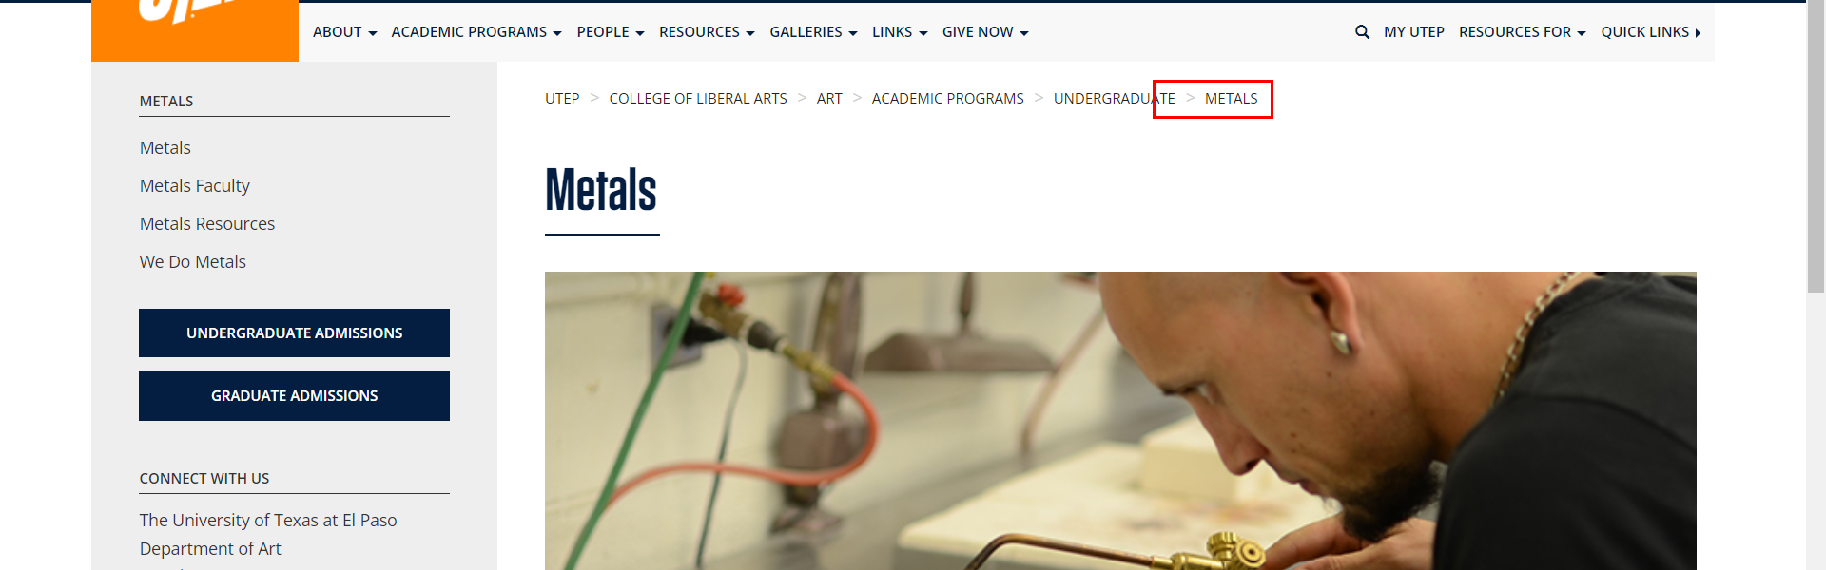

• Broken link on <https://www.utep.edu/liberalarts/art/academic-programs/undergraduate/metals/we-do-metals.html> on **Main Content (Top small navigation)** section, the broken link is displayed as: **metals** and the link is pointing to : <https://www.utep.edu/liberalarts/art/academic-programs/undergraduate/metals/>

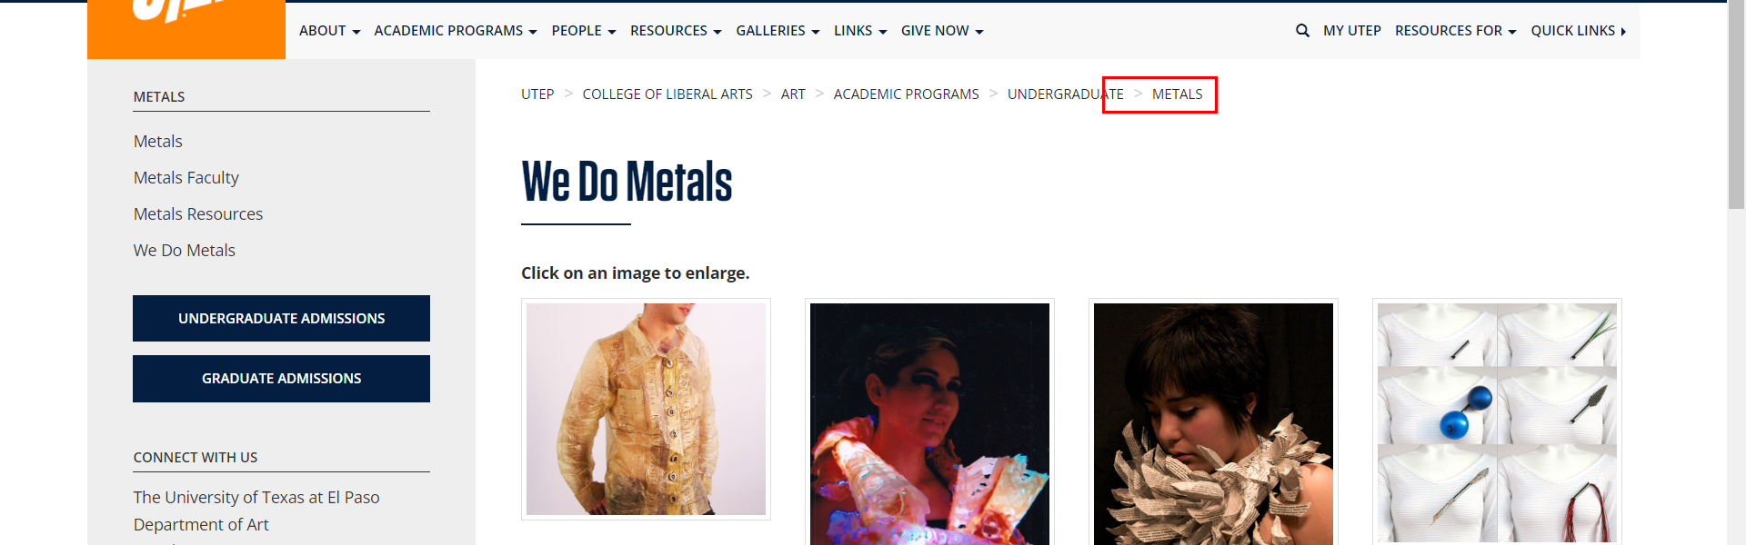

• Broken link on <https://www.utep.edu/liberalarts/art/academic-programs/undergraduate/painting/painting-faculty.html> on **Main Content (Top small navigation)** section, the broken link is displayed as: **painting** and the link is pointing to : <https://www.utep.edu/liberalarts/art/academic-programs/undergraduate/painting/>

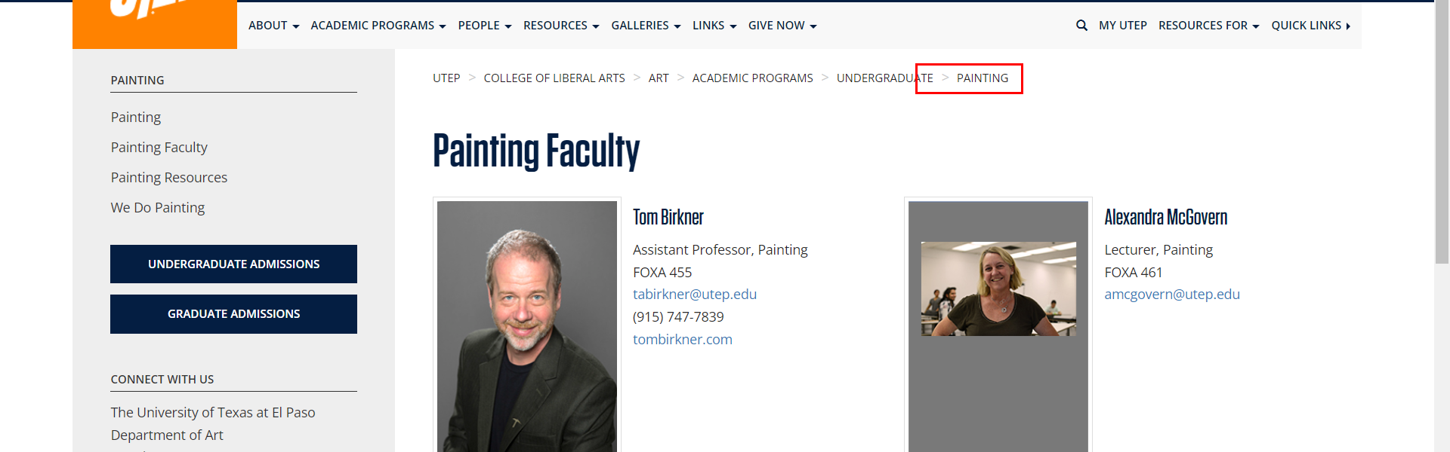

• Broken link on <https://www.utep.edu/liberalarts/art/academic-programs/undergraduate/painting/painting-resources.html> on **Main Content (Top small navigation)** section, the broken link is displayed as: **painting** and the link is pointing to : <https://www.utep.edu/liberalarts/art/academic-programs/undergraduate/painting/>

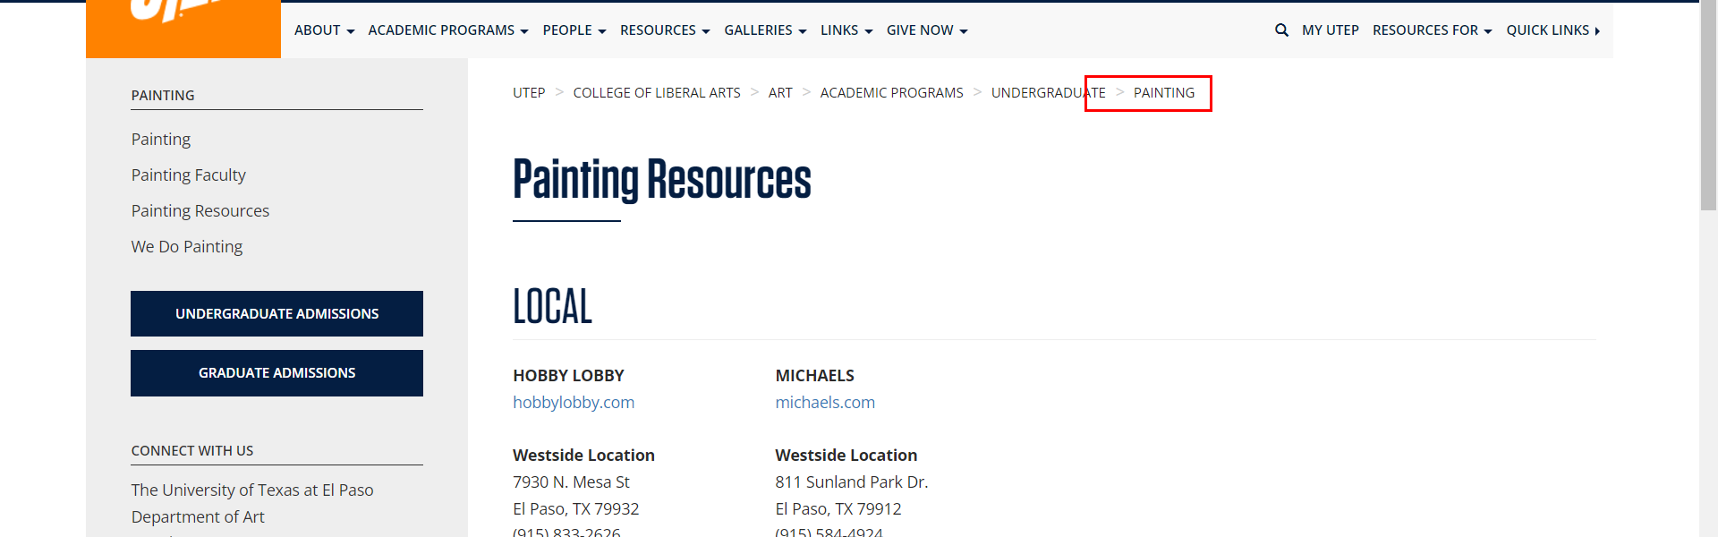

• Broken link on <https://www.utep.edu/liberalarts/art/academic-programs/undergraduate/painting/painting.html> on **Main Content (Top small navigation)** section, the broken link is displayed as: **painting** and the link is pointing to : <https://www.utep.edu/liberalarts/art/academic-programs/undergraduate/painting/>

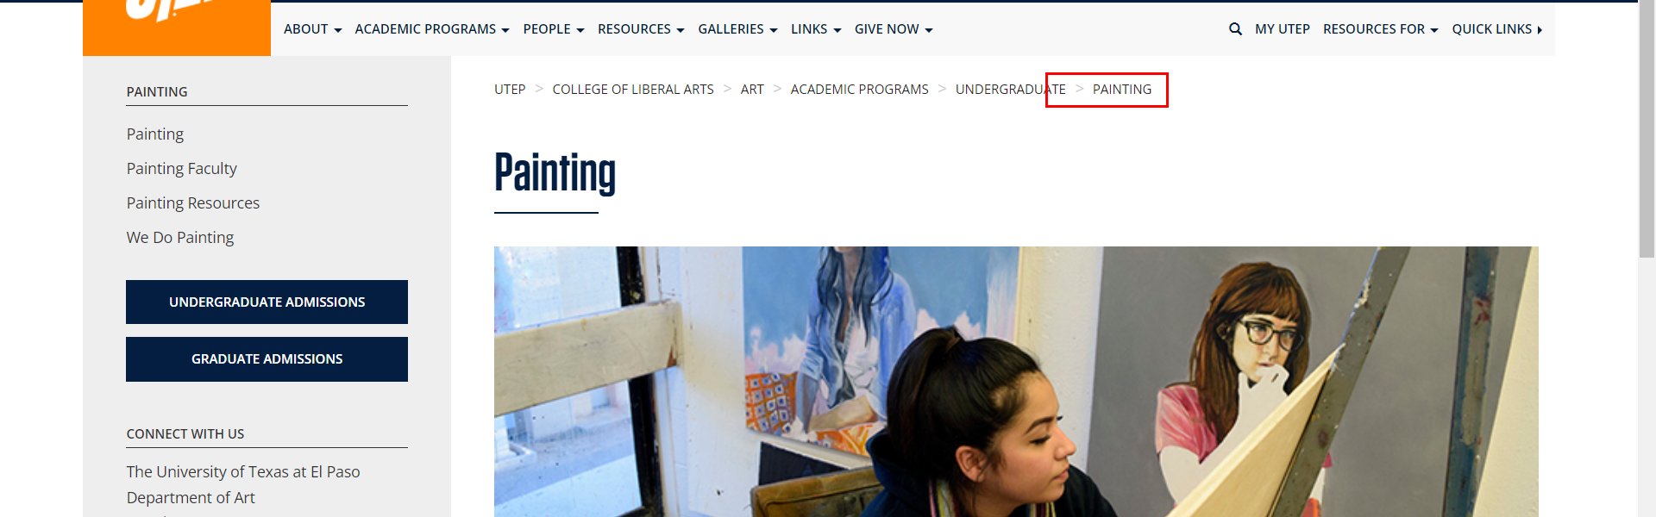

• Broken link on <https://www.utep.edu/liberalarts/art/academic-programs/undergraduate/painting/we-do-painting.html> on **Main Content (Top small navigation)** section, the broken link is displayed as: **painting** and the link is pointing to : <https://www.utep.edu/liberalarts/art/academic-programs/undergraduate/painting/>

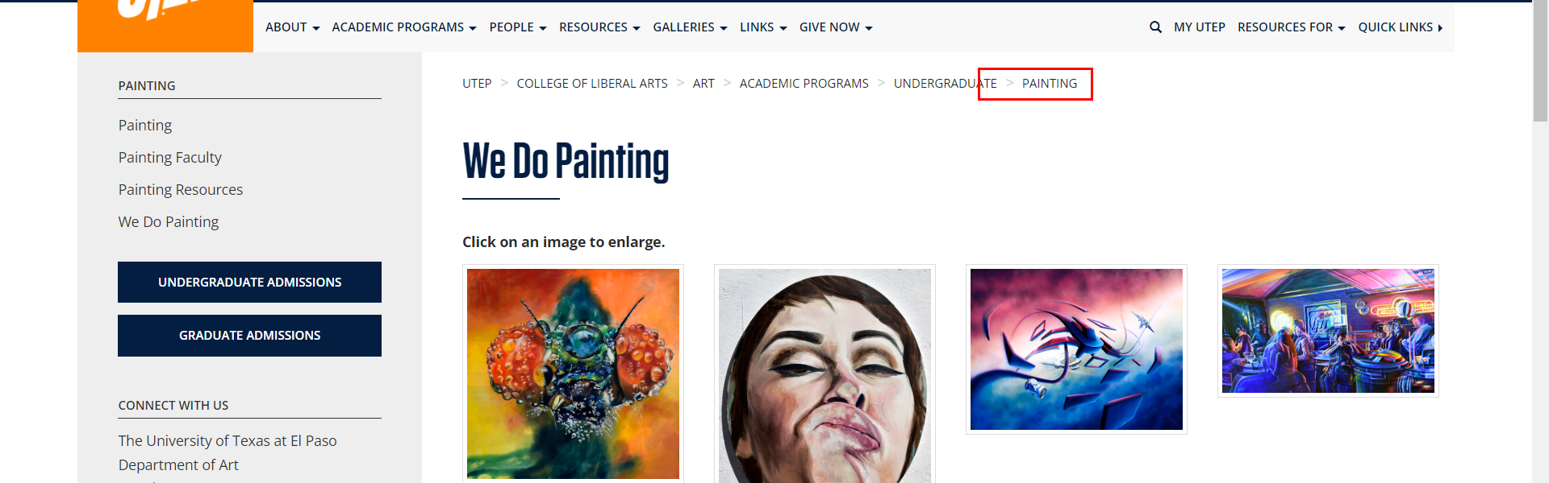

• Broken link on <https://www.utep.edu/liberalarts/art/academic-programs/undergraduate/printmaking/printmaking-faculty.html> on **Main Content (Top small navigation)** section, the broken link is displayed as: **printmaking** and the link is pointing to : <https://www.utep.edu/liberalarts/art/academic-programs/undergraduate/printmaking/>

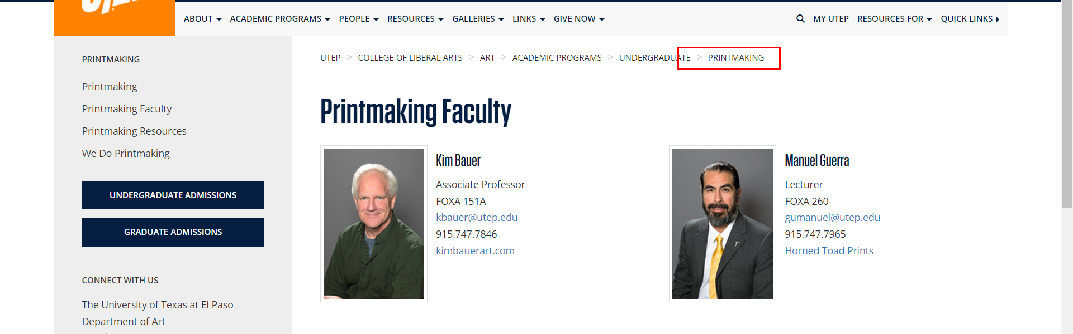

• Broken link on <https://www.utep.edu/liberalarts/art/academic-programs/undergraduate/printmaking/printmaking-resources.html> on **Main Content (Top small navigation)** section, the broken link is displayed as: **printmaking** and the link is pointing to : <https://www.utep.edu/liberalarts/art/academic-programs/undergraduate/printmaking/>

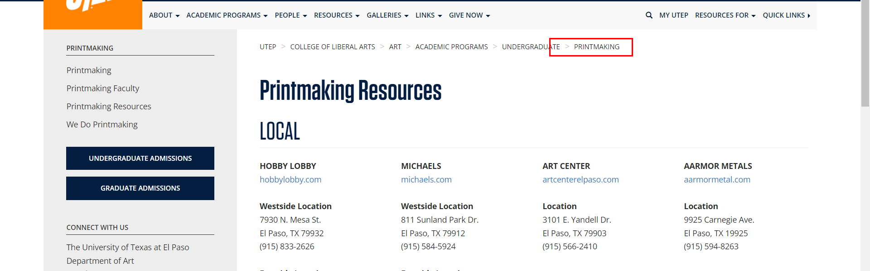

• Broken link on <https://www.utep.edu/liberalarts/art/academic-programs/undergraduate/printmaking/printmaking.html> on **Main Content (Top small navigation)** section, the broken link is displayed as: **printmaking** and the link is pointing to : <https://www.utep.edu/liberalarts/art/academic-programs/undergraduate/printmaking/>

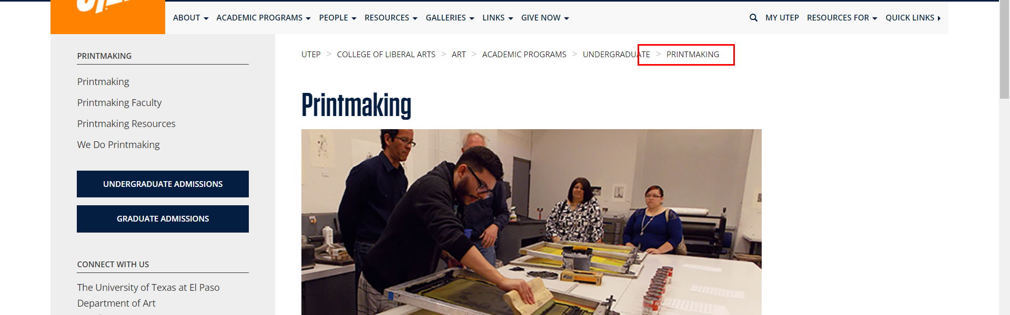

• Broken link on <https://www.utep.edu/liberalarts/art/academic-programs/undergraduate/printmaking/we-do-printmaking.html> on **Main Content (Top small navigation)** section, the broken link is displayed as: **printmaking** and the link is pointing to : <https://www.utep.edu/liberalarts/art/academic-programs/undergraduate/printmaking/>

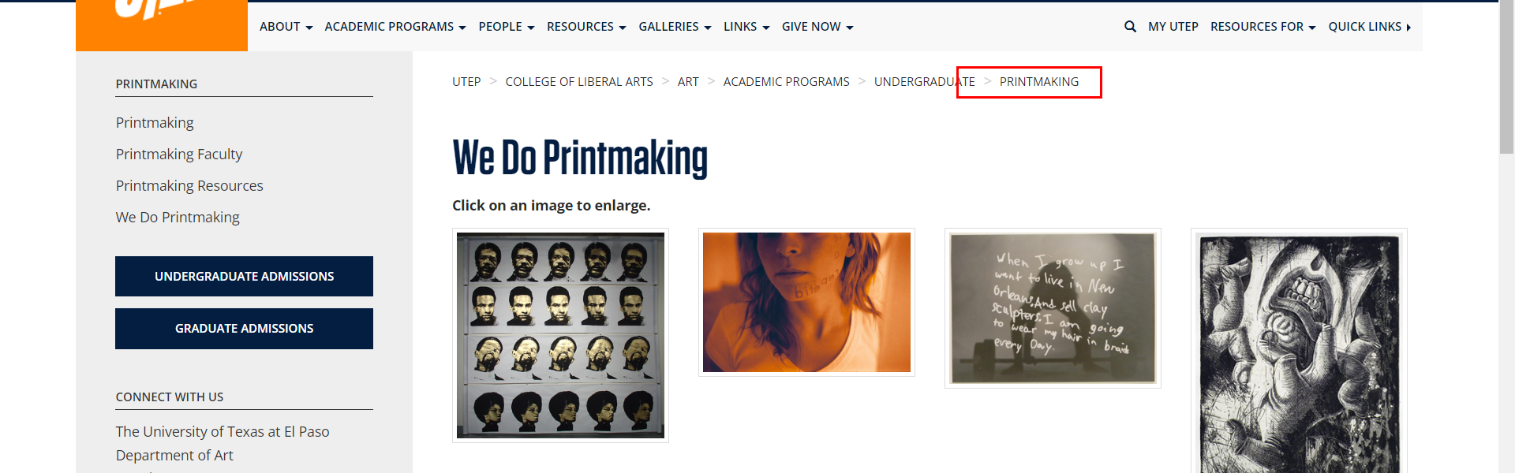

• Broken link on <https://www.utep.edu/liberalarts/art/academic-programs/undergraduate/professional-practices/professional-practices-faculty.html> on **Main Content (Top small navigation)** section, the broken link is displayed as: **professional-practices** and the link is pointing to : <https://www.utep.edu/liberalarts/art/academic-programs/undergraduate/professional-practices/>

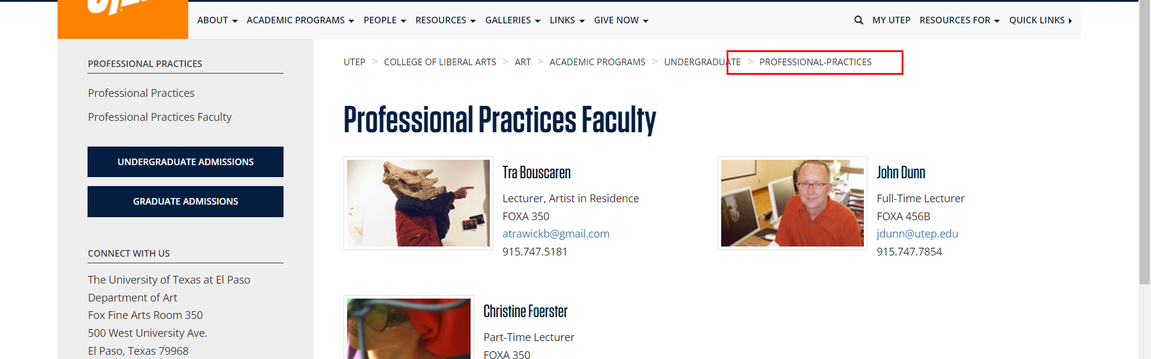

• Broken link on <https://www.utep.edu/liberalarts/art/academic-programs/undergraduate/professional-practices/professional-practices.html> on **Main Content (Top small navigation)** section, the broken link is displayed as: **professional-practices** and the link is pointing to : <https://www.utep.edu/liberalarts/art/academic-programs/undergraduate/professional-practices/>

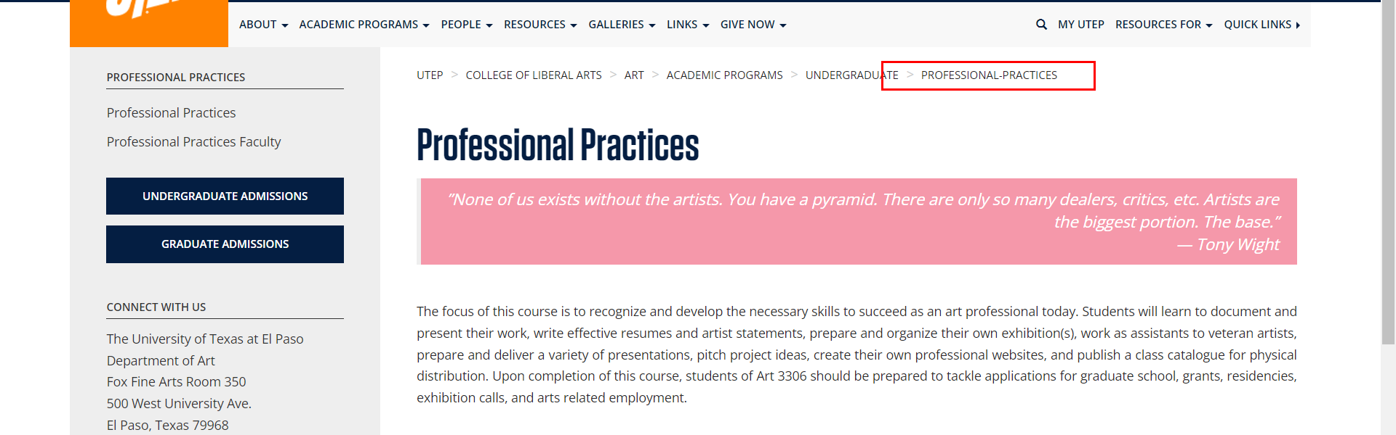

• Broken link on <https://www.utep.edu/liberalarts/art/academic-programs/undergraduate/sculpture/sculpture-faculty.html> on **Main Content (Top small navigation)** section, the broken link is displayed as: **sculpture** and the link is pointing to : <https://www.utep.edu/liberalarts/art/academic-programs/undergraduate/sculpture/>

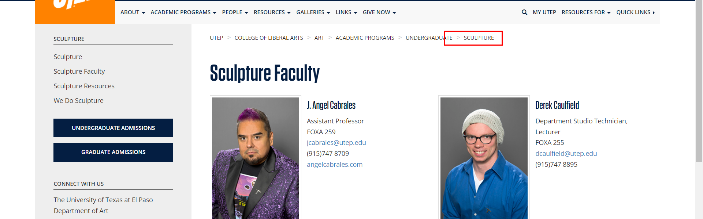

• Broken link on <https://www.utep.edu/liberalarts/art/academic-programs/undergraduate/sculpture/sculpture-resources.html> on **Main Content (Top small navigation)** section, the broken link is displayed as: **sculpture** and the link is pointing to : <https://www.utep.edu/liberalarts/art/academic-programs/undergraduate/sculpture/>

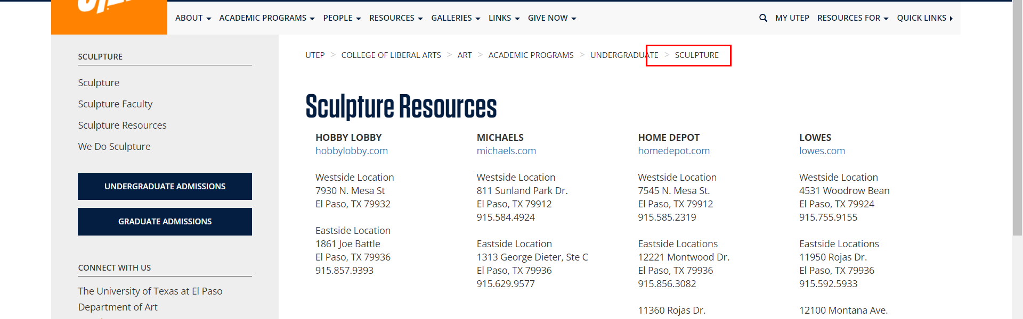

• Broken link on <https://www.utep.edu/liberalarts/art/academic-programs/undergraduate/sculpture/sculpture.html> on **Main Content (Top small navigation)** section, the broken link is displayed as: **sculpture** and the link is pointing to : <https://www.utep.edu/liberalarts/art/academic-programs/undergraduate/sculpture/>

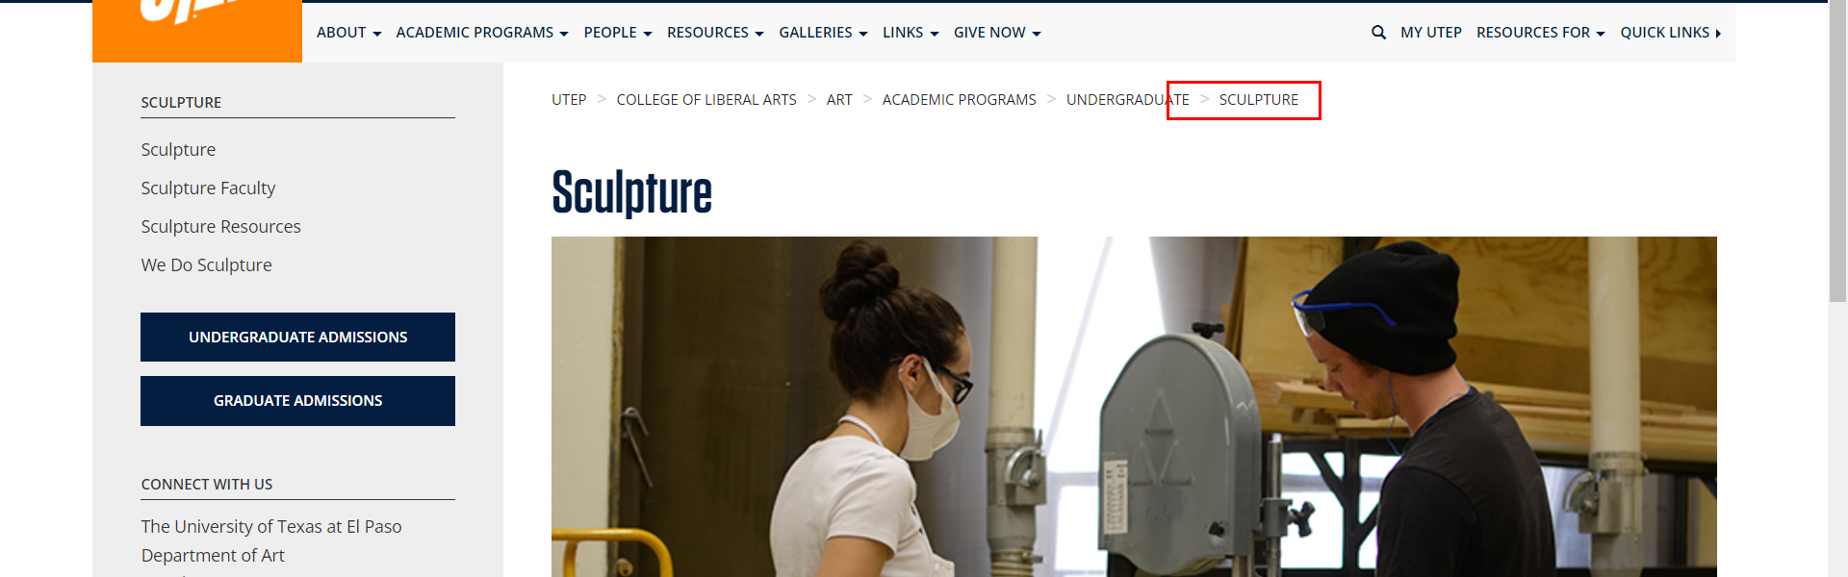

• Broken link on <https://www.utep.edu/liberalarts/art/academic-programs/undergraduate/sculpture/we-do-sculpture.html> on **Main Content (Top small navigation)** section, the broken link is displayed as: **sculpture** and the link is pointing to : <https://www.utep.edu/liberalarts/art/academic-programs/undergraduate/sculpture/>

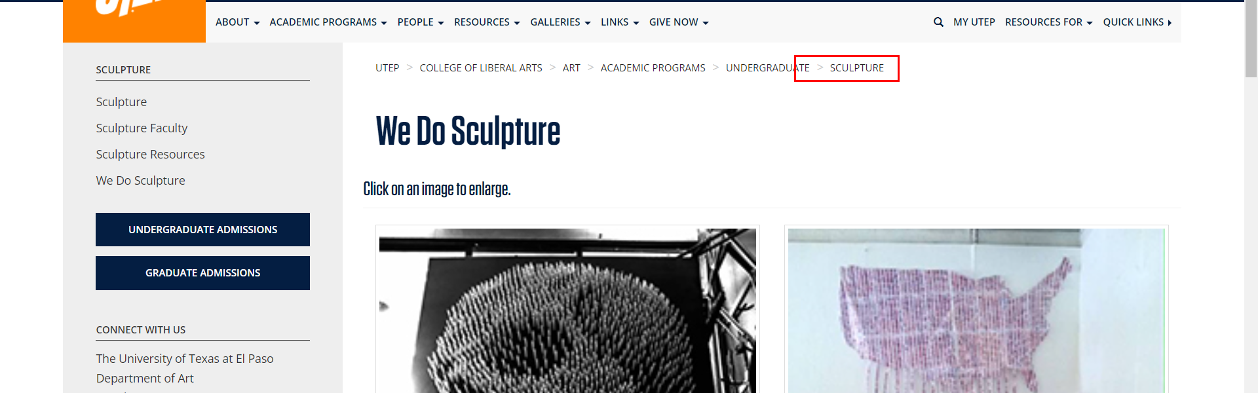

• Broken link on <https://www.utep.edu/liberalarts/art/people/do-art-alumni.html> on **Main Content (Top small navigation)** section, the broken link is displayed as: **People** and the link is pointing to : <https://www.utep.edu/liberalarts/art/people/>

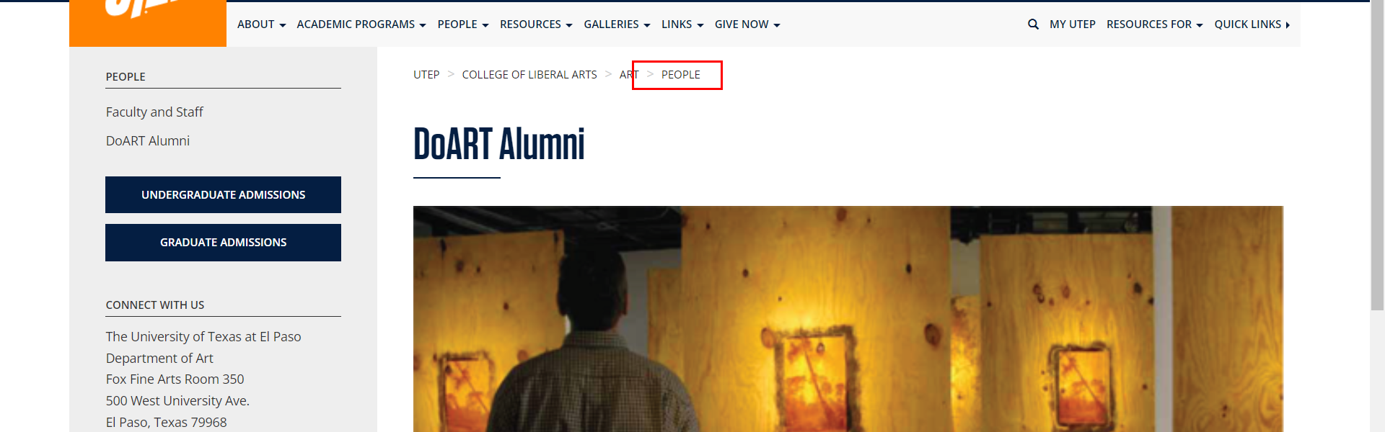

• Broken link on <https://www.utep.edu/liberalarts/art/people/faculty-staff.html> on **Main Content (Top small navigation)** section, the broken link is displayed as: **People** and the link is pointing to : <https://www.utep.edu/liberalarts/art/people/>

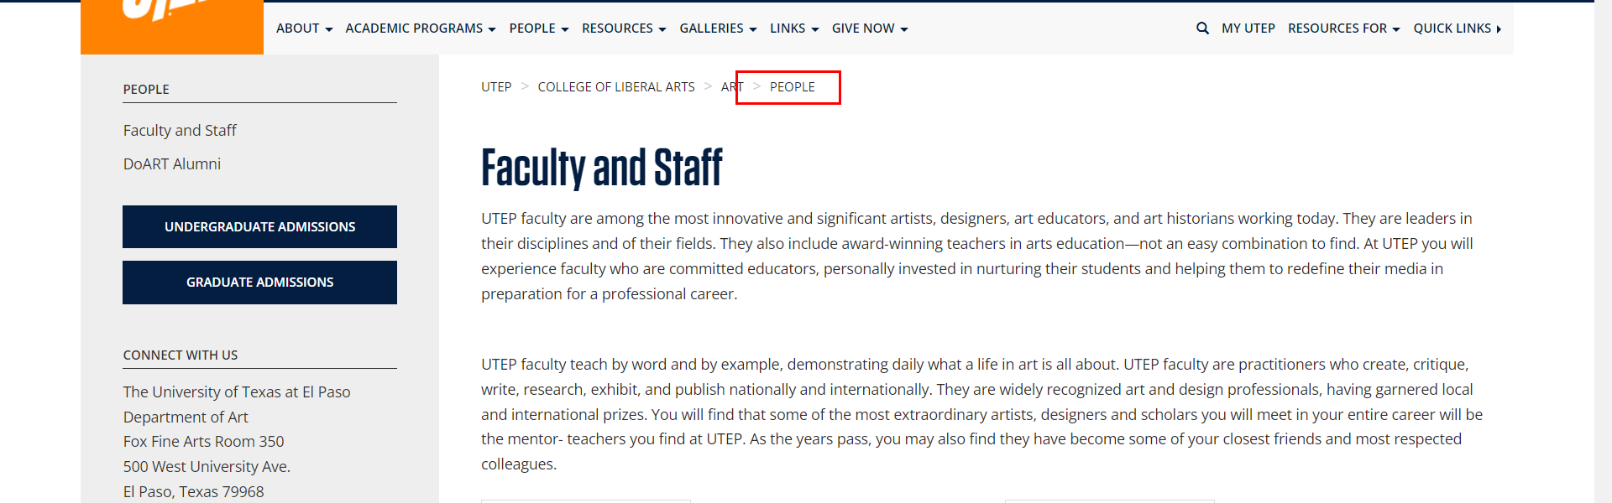

• Broken link on <https://www.utep.edu/liberalarts/art/people/faculty.html> on **Main Content (Top small navigation)** section, the broken link is displayed as: **People** and the link is pointing to : <https://www.utep.edu/liberalarts/art/people/>

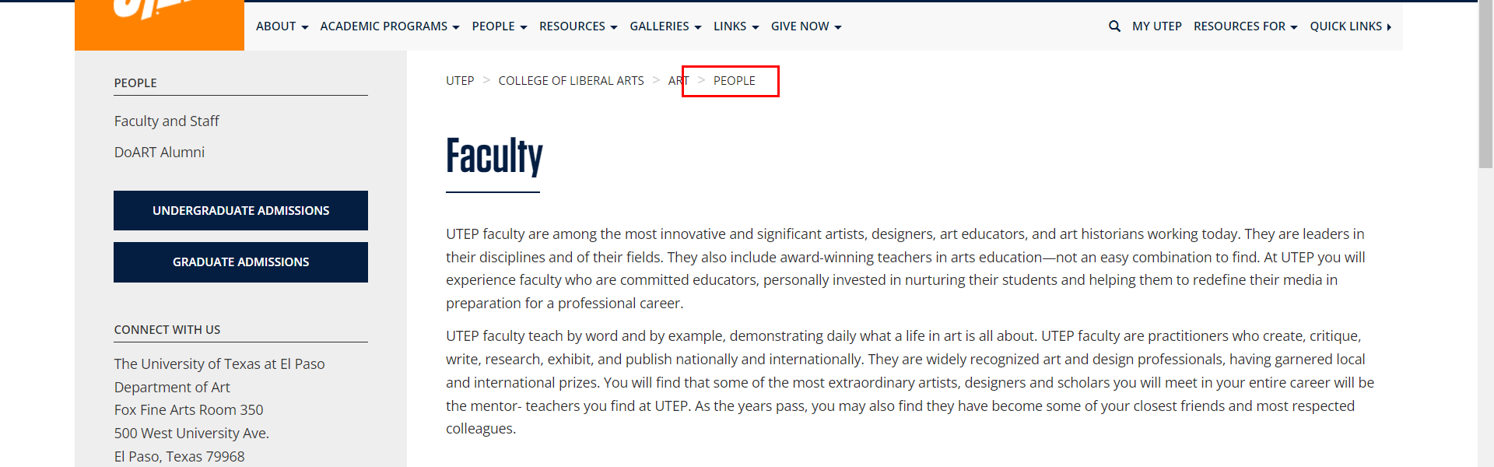

• Broken link on <https://www.utep.edu/liberalarts/art/resources/do-art-and-the-rubin-center.html> on **Main Content (Top small navigation)** section, the broken link is displayed as: **Resources** and the link is pointing to : <https://www.utep.edu/liberalarts/art/resources/>

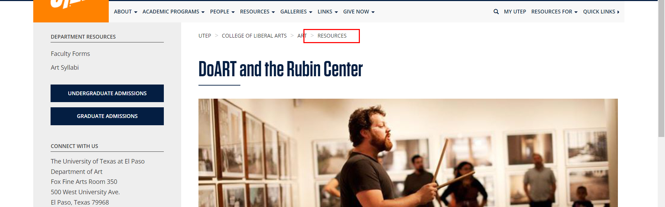

• Broken link on <https://www.utep.edu/liberalarts/art/resources/departmental/faculty-forms.html> on **Main Content (Top small navigation)** section, the broken link is displayed as: **Resources** and the link is pointing to : <https://www.utep.edu/liberalarts/art/resources/>

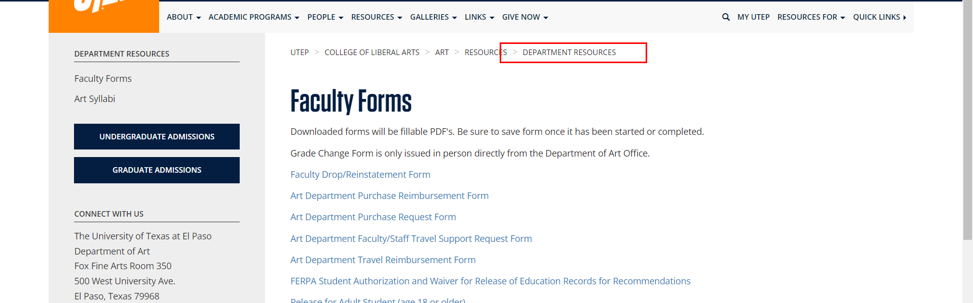

• Broken link on <https://www.utep.edu/liberalarts/art/resources/departmental/index.html> on **Main Content (Top small navigation)** section, the broken link is displayed as: **Resources** and the link is pointing to : <https://www.utep.edu/liberalarts/art/resources/>

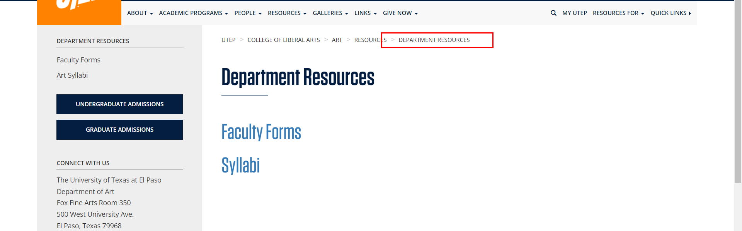

• Broken link on <https://www.utep.edu/liberalarts/art/resources/departmental/syllabi.html> on **Main Content (Top small navigation)** section, the broken link is displayed as: **Resources** and the link is pointing to : <https://www.utep.edu/liberalarts/art/resources/>

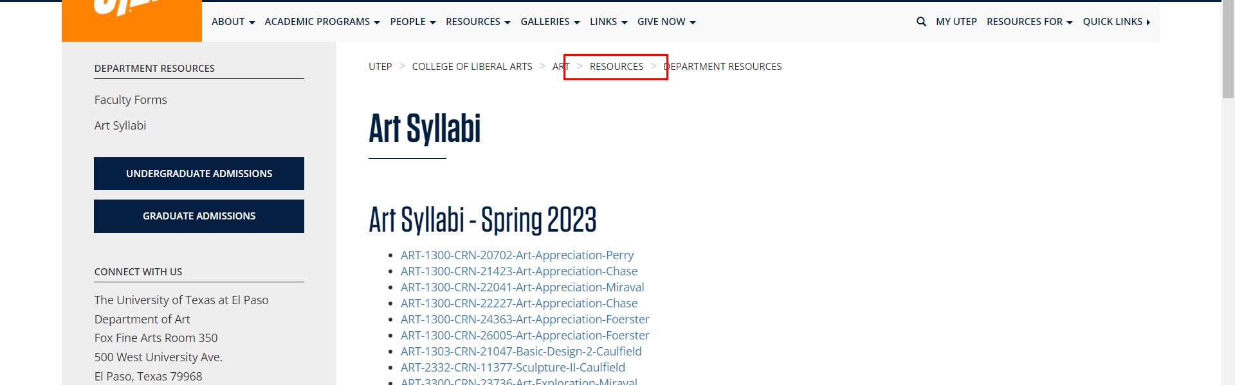

• Broken link on <https://www.utep.edu/liberalarts/art/resources/student/faqs.html> on **Main Content (Top small navigation)** section, the broken link is displayed as: **Resources** and the link is pointing to : <https://www.utep.edu/liberalarts/art/resources/>

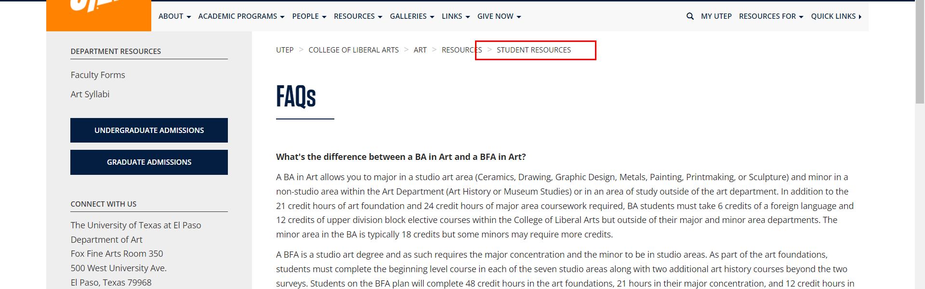

• Broken link on <https://www.utep.edu/liberalarts/art/resources/student/index.html> on **Main Content (Top small navigation)** section, the broken link is displayed as: **Resources** and the link is pointing to : <https://www.utep.edu/liberalarts/art/resources/>

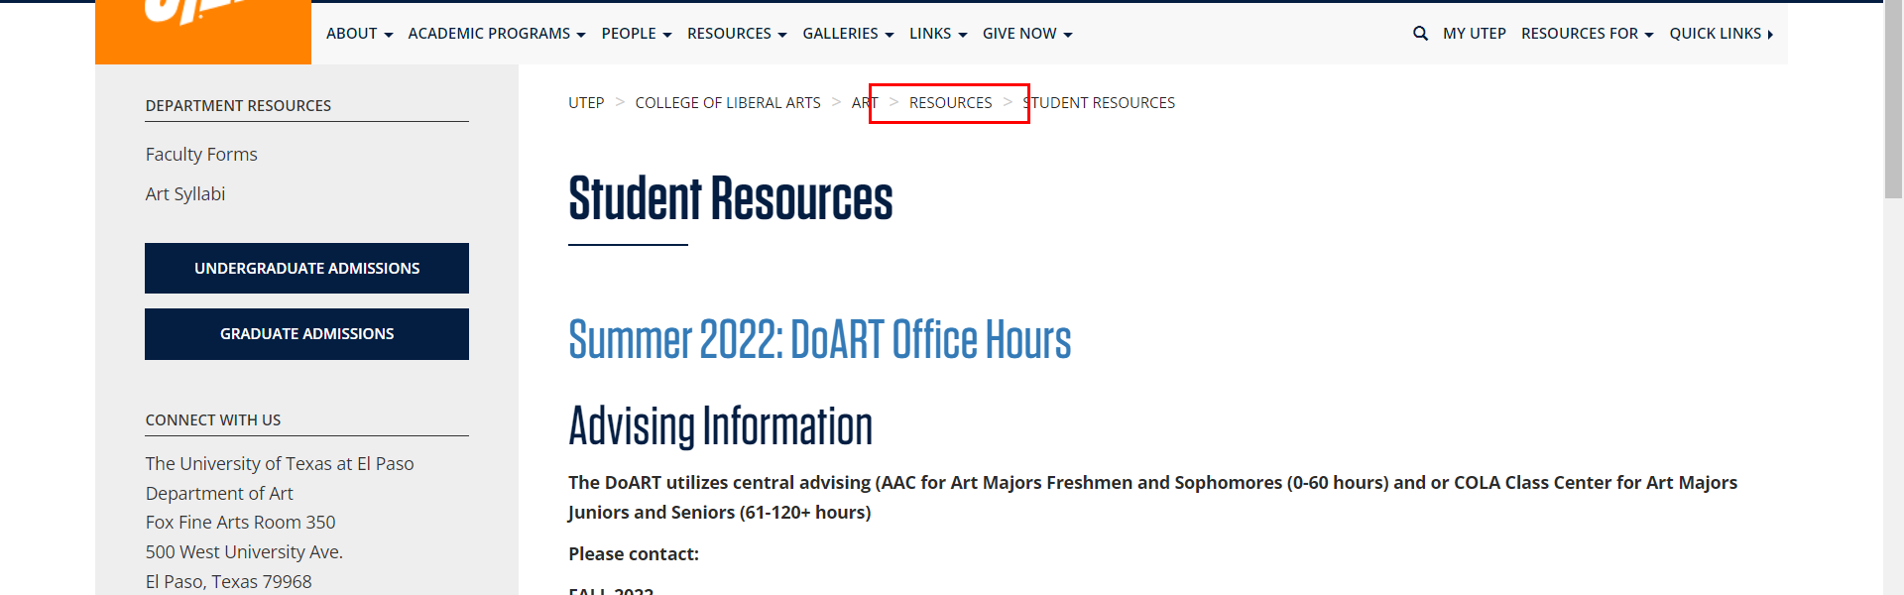

• Broken link on <https://www.utep.edu/liberalarts/art/resources/student/open-studio-lab-hours.html> on **Main Content (Top small navigation)** section, the broken link is displayed as: **Resources** and the link is pointing to : <https://www.utep.edu/liberalarts/art/resources/>

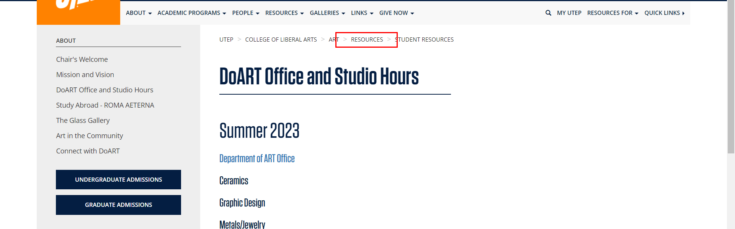

• Broken link on <https://www.utep.edu/liberalarts/art/resources/student/open-studio-lab-hours.html> on **Main Content** section, the broken link is displayed as: and the link is pointing to : <https://www.utep.edu/liberalarts/art/resources/student/SU-21_DoART-Office-Open-Hours-copy-2.pdf>

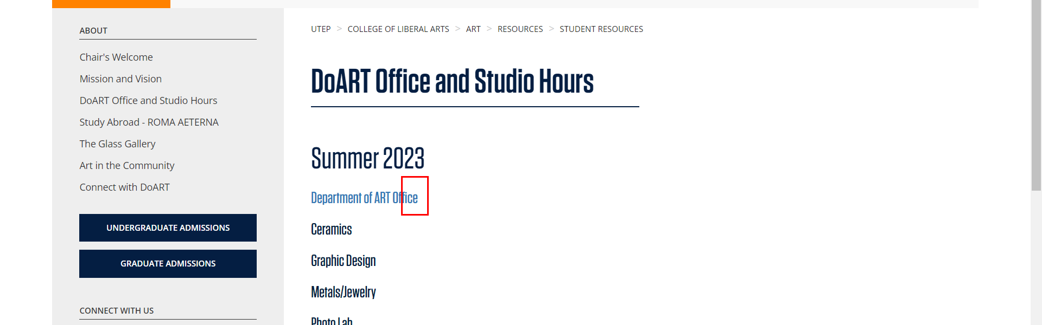

• Broken link on <https://www.utep.edu/liberalarts/art/resources/student/open-studio-lab-hours.html> on **Main Content** section, the broken link is displayed as: and the link is pointing to : <https://www.utep.edu/liberalarts/art/resources/student/2018SPRING_LABHOURS.pdf>

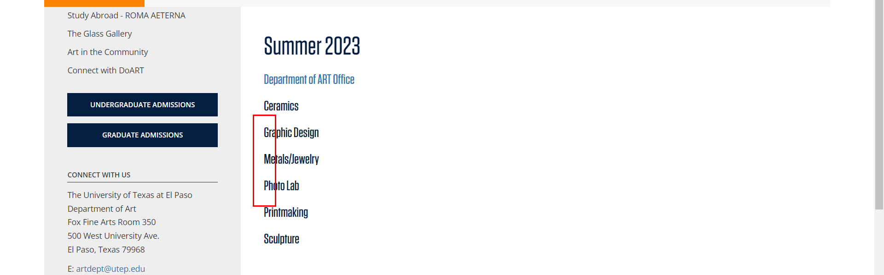

• Broken link on <https://www.utep.edu/liberalarts/art/resources/student/open-studio-lab-hours.html> on **Main Content** section, the broken link is displayed as: and the link is pointing to : <https://www.utep.edu/liberalarts/art/resources/student/Sp20_DoART-Office-Open-Hours-copy-2.pdf>

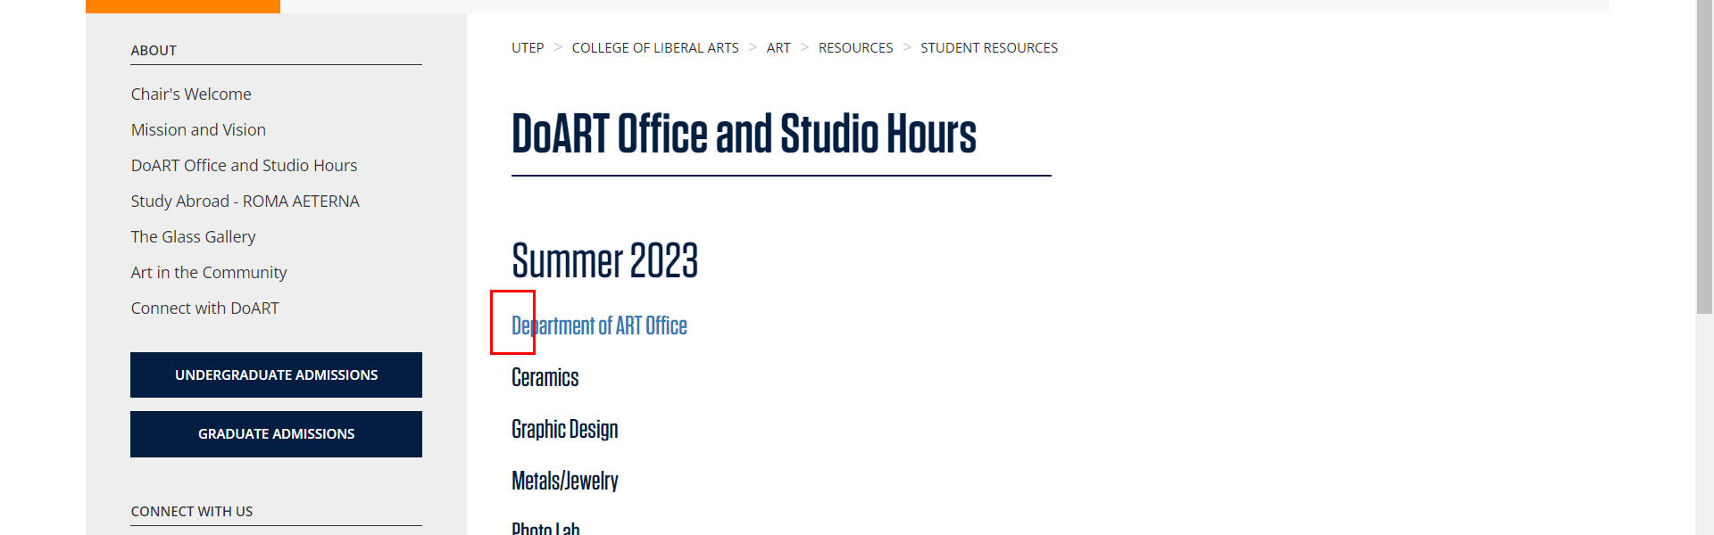

• Broken link on <https://www.utep.edu/liberalarts/art/resources/student/open-studio-lab-hours.html> on **Main Content** section, the broken link is displayed as: and the link is pointing to : <https://www.utep.edu/liberalarts/art/resources/student/Sp20-GD-LAB-MONITOR-SCHEDULE-2020.pdf>

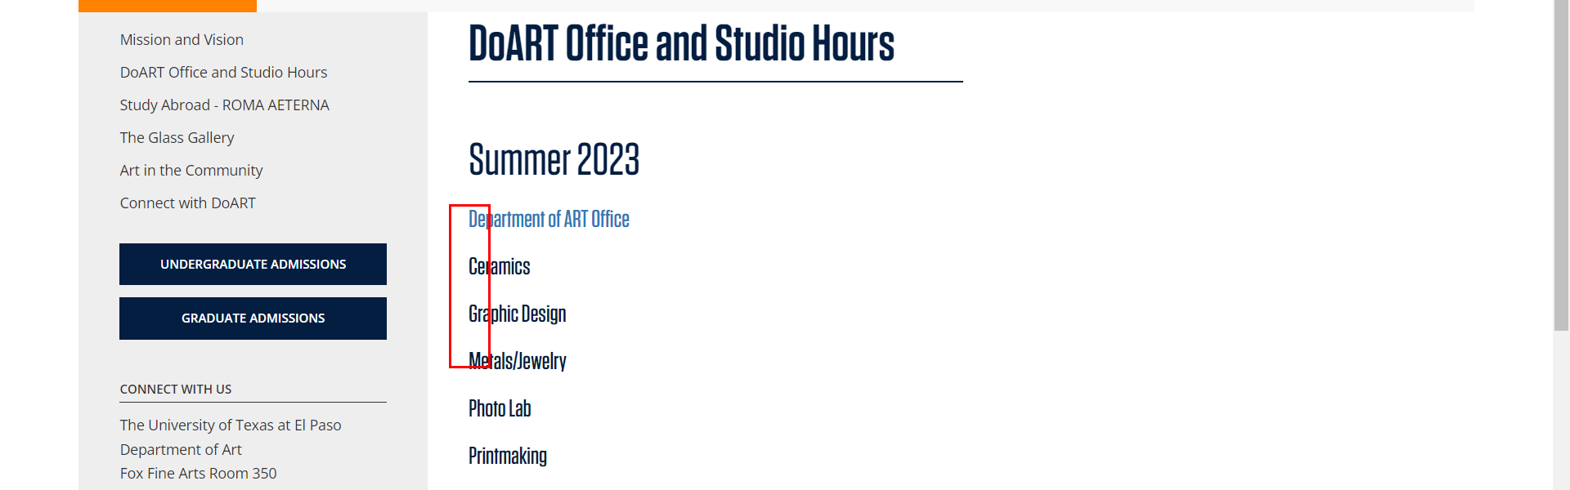

• Broken link on <https://www.utep.edu/liberalarts/art/resources/student/open-studio-lab-hours.html> on **Main Content** section, the broken link is displayed as: and the link is pointing to : <https://www.utep.edu/liberalarts/art/resources/Sp-18-studio-hours-Printmaking.pdf>

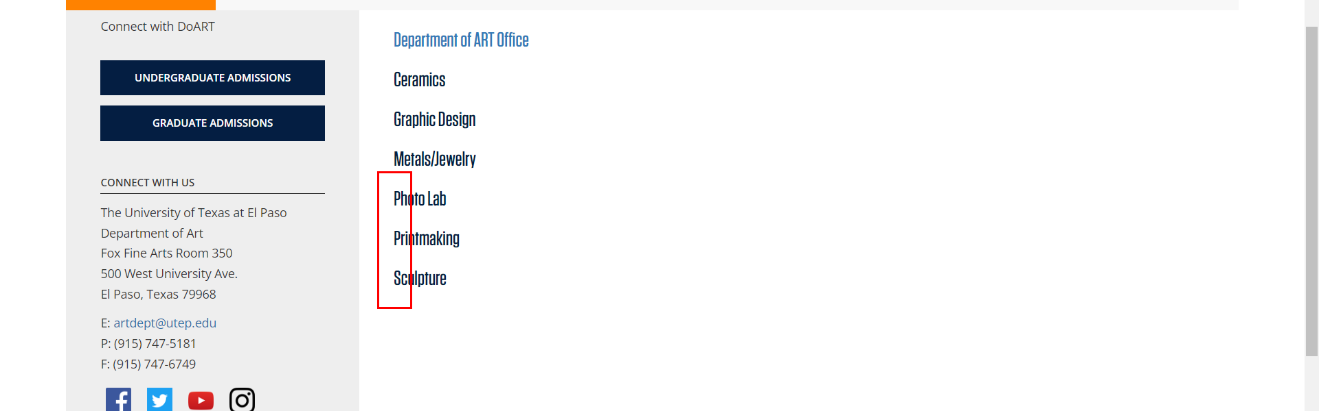

• Broken link on <https://www.utep.edu/liberalarts/art/resources/student/open-studio-lab-hours.html> on **Main Content** section, the broken link is displayed as: and the link is pointing to : <https://www.utep.edu/liberalarts/art/resources/student/Print-Lab-Hours-Spring-2020.pdf>



• Broken link on <https://www.utep.edu/liberalarts/art/resources/student/open-studio-lab-hours.html> on **Main Content** section, the broken link is displayed as: and the link is pointing to : <https://www.utep.edu/liberalarts/art/resources/student/SPRING-2020.pdf>

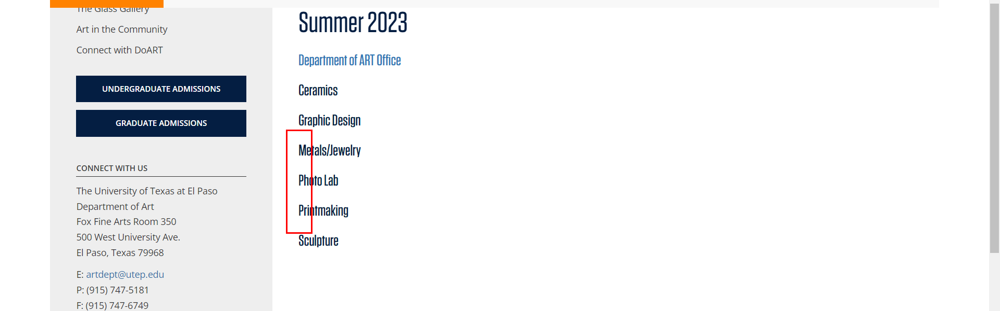

• Broken link on <https://www.utep.edu/liberalarts/art/resources/student/open-studio-lab-hours.html> on **Main Content** section, the broken link is displayed as: and the link is pointing to : <https://www.utep.edu/liberalarts/art/resources/student/Sculpture-Studio-Hours-Spring-2018.pdf>

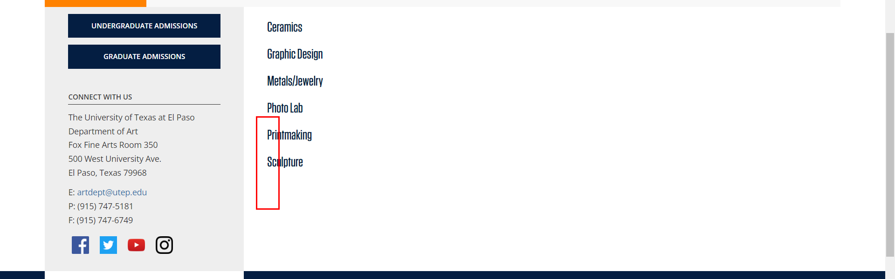

• Broken link on <https://www.utep.edu/liberalarts/art/resources/student/open-studio-lab-hours.html> on **Main Content** section, the broken link is displayed as: and the link is pointing to : <https://www.utep.edu/liberalarts/art/resources/student/Sculpture-Studio-Hours-Spring-2020.pdf>



• Broken link on <https://www.utep.edu/liberalarts/art/resources/student/open-studio-lab-hours.html> on **Main Content** section, the broken link is displayed as: and the link is pointing to : <https://www.utep.edu/liberalarts/art/resources/student/SPRING-2020-Photo.pdf>



• Broken link on <https://www.utep.edu/liberalarts/art/resources/student/scholarships-workstudy-awards.html> on **Main Content (Top small navigation)** section, the broken link is displayed as: **Resources** and the link is pointing to : <https://www.utep.edu/liberalarts/art/resources/>

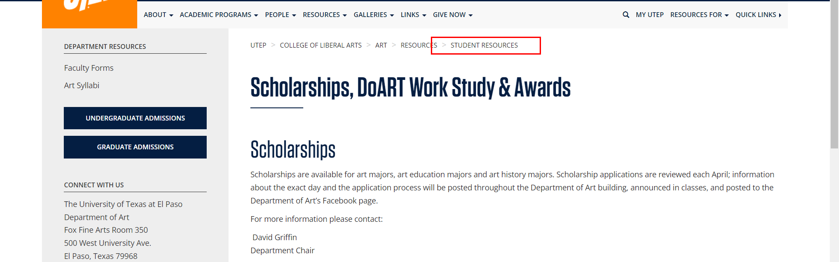

• Broken link on <https://www.utep.edu/liberalarts/art/resources/student/student-organizations.html> on **Main Content (Top small navigation)** section, the broken link is displayed as: **Resources** and the link is pointing to : <https://www.utep.edu/liberalarts/art/resources/>

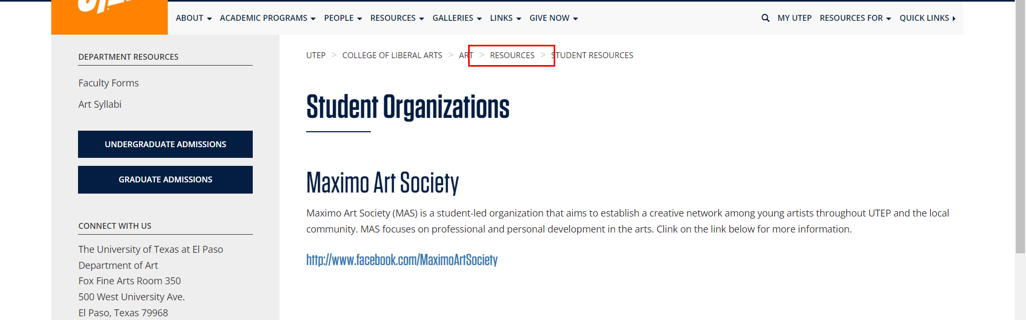

• Broken link on <https://www.utep.edu/liberalarts/art/resources/student/study-abroad.html> on **Main Content (Top small navigation)** section, the broken link is displayed as: **Resources** and the link is pointing to : <https://www.utep.edu/liberalarts/art/resources/>

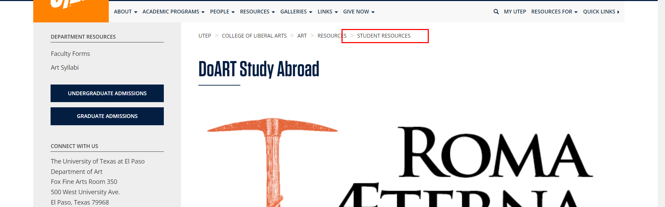

• Broken link on <https://www.utep.edu/liberalarts/art/resources/student/the-glass-gallery.html> on **Main Content (Top small navigation)** section, the broken link is displayed as: **Resources** and the link is pointing to : <https://www.utep.edu/liberalarts/art/resources/>

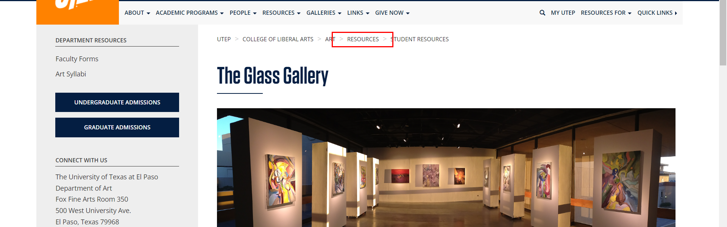

• Broken link on <https://www.utep.edu/liberalarts/art/resources/student/utep-for-credit-internship-policy.html> on **Main Content (Top small navigation)** section, the broken link is displayed as: **Resources** and the link is pointing to : <https://www.utep.edu/liberalarts/art/resources/>

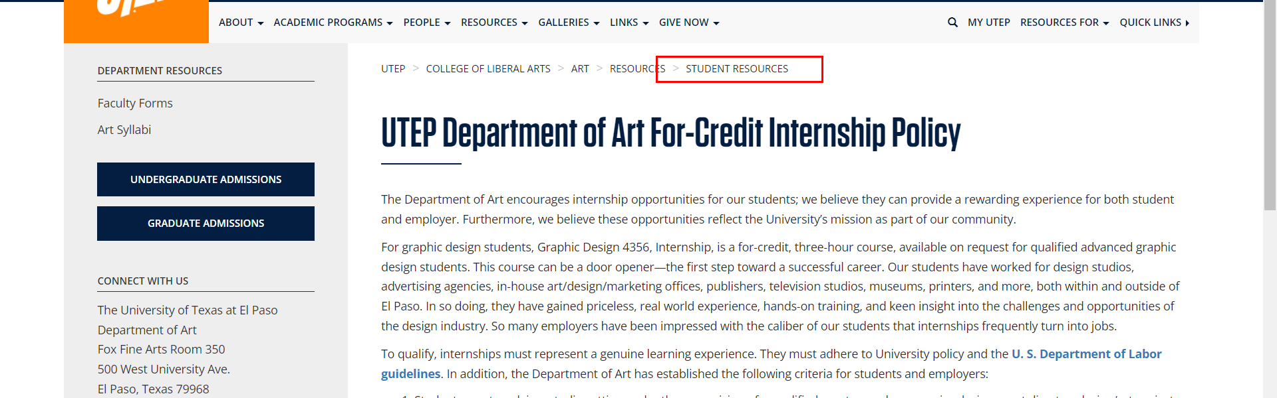

• Broken link on <https://www.utep.edu/liberalarts/art/resources/student/advising/current-students.html> on **Main Content (Top small navigation)** section, the broken link is displayed as: **Advising** and the link is pointing to : <https://www.utep.edu/liberalarts/art/resources/student/advising/>

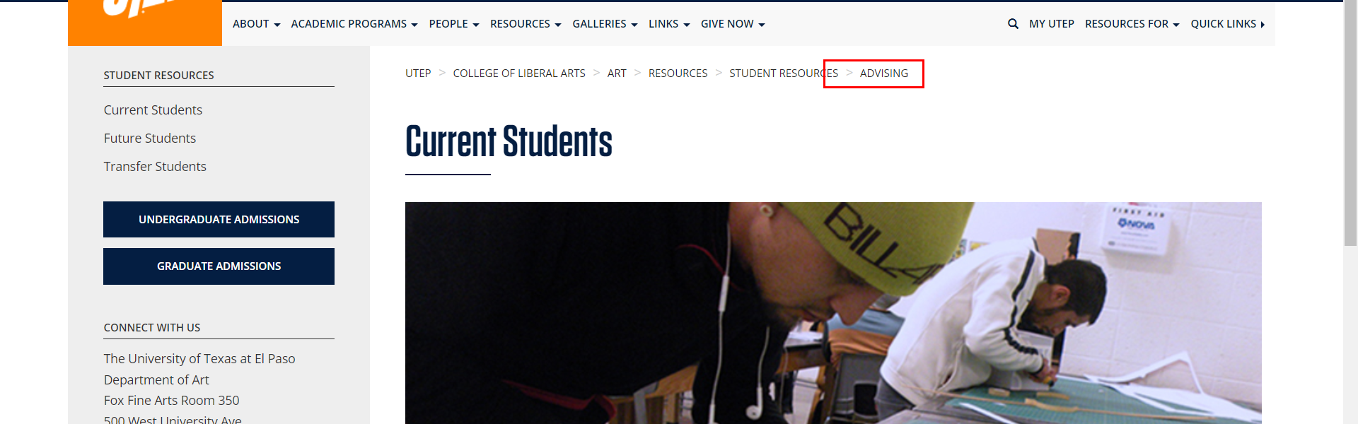

• Broken link on <https://www.utep.edu/liberalarts/art/resources/student/advising/current-students.html> on **Main Content (Top small navigation)** section, the broken link is displayed as: **Resources** and the link is pointing to : <https://www.utep.edu/liberalarts/art/resources/>

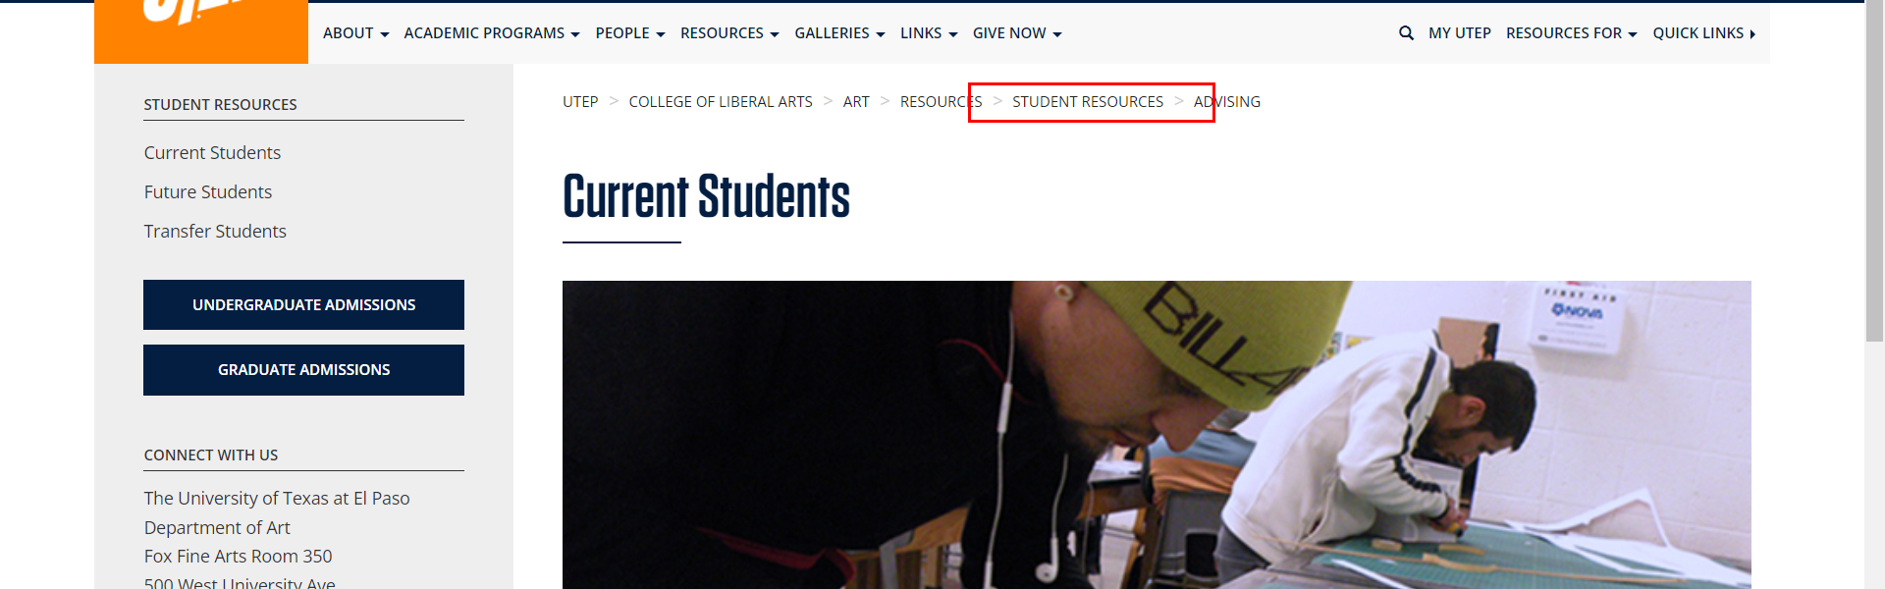

• Broken link on <https://www.utep.edu/liberalarts/art/resources/student/advising/future-students.html> on **Main Content (Top small navigation)** section, the broken link is displayed as: **Resources** and the link is pointing to : <https://www.utep.edu/liberalarts/art/resources/>

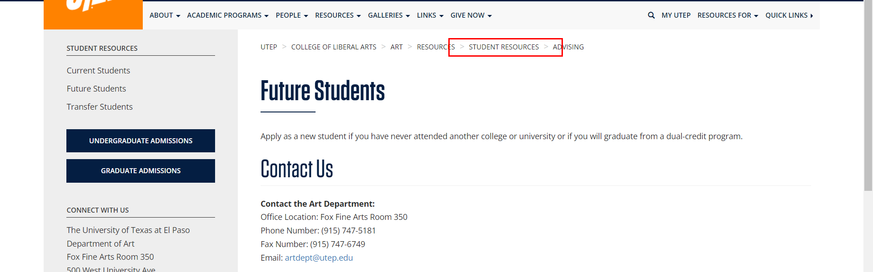

• Broken link on <https://www.utep.edu/liberalarts/art/resources/student/advising/future-students.html> on **Main Content (Top small navigation)** section, the broken link is displayed as: **Advising** and the link is pointing to : <https://www.utep.edu/liberalarts/art/resources/student/advising/>

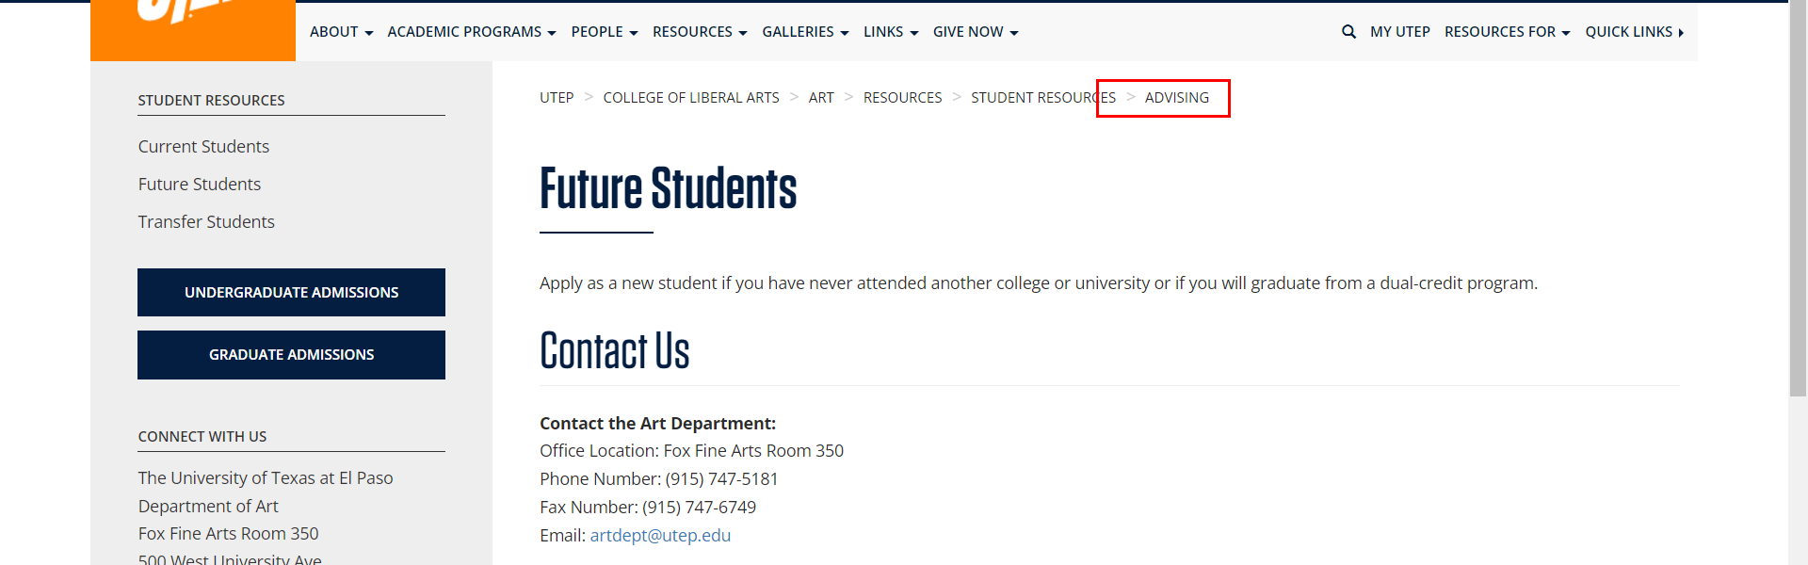

• Broken link on <https://www.utep.edu/liberalarts/art/resources/student/advising/transfer-students.html> on **Main Content (Top small navigation)** section, the broken link is displayed as: **Advising** and the link is pointing to : <https://www.utep.edu/liberalarts/art/resources/student/advising/>

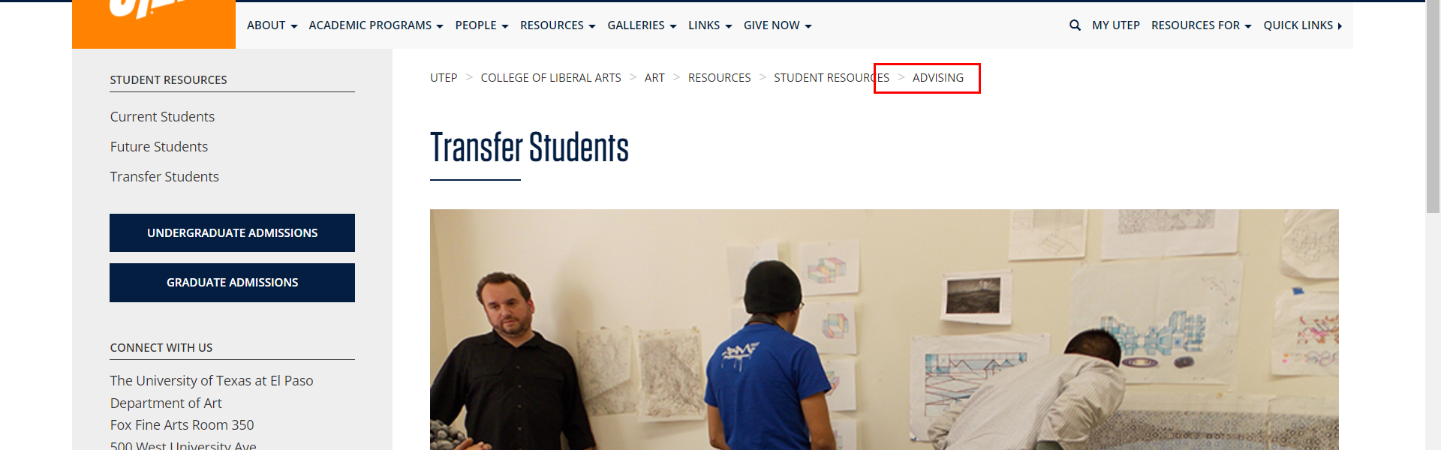

• Broken link on <https://www.utep.edu/liberalarts/art/resources/student/advising/transfer-students.html> on **Main Content (Top small navigation)** section, the broken link is displayed as: **Resources** and the link is pointing to : <https://www.utep.edu/liberalarts/art/resources/>

